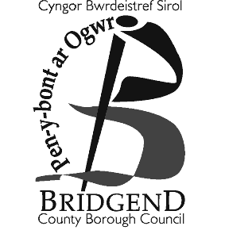

Council Tax Exemption/Discount:
Significant Cognitive Impairment

Anyone who is medically certified as having a Significant Cognitive Impairment (SCI) may be eligible for a Council Tax exemption or discount. A person is subject to a SCI if they have a severe and permanent mental condition or neurological change that impacts on the brain’s ability to function and has a significant impact on that individual’s daily life.

Conditions that can lead to a SCI or mental ill health include Alzheimer’s disease and other forms of dementia, Parkinson’s disease, severe learning difficulties or a stroke, but many others may apply. Having one of these conditions does not in itself mean that a person will be diagnosed as having a SCI by a doctor. To be eligible for the exemption/discount, the person must be diagnosed as having a SCI by a doctor and must also be entitled to one of the benefits listed on this form.

Council Tax Exemption/Discount:
- If you have been diagnosed as having a SCI by a doctor and you are living alone or only with others who have a SCI, you will be exempt from paying Council Tax.
- If you have been diagnosed as having a SCI by a doctor and you live with one adult who is eligible to pay council tax, your household will receive a 25% discount.
- If you have been diagnosed as having a SCI by a doctor and you live with 2 or more adults who are eligible to pay council tax there will be no discount.

Application Form for Exemption/Discount

PART A: Personal information

Full name of person applying to be disregarded:

National Insurance Number: Date of Birth:

Address:
Postcode:
Telephone number: Email:

Total number of adults (residents over the age of 18) living at this address:

PART C: Doctor or Medical Practitioner’s declaration
(to be completed by the Doctor/Medical Practitioner)

Name of doctor/medical practitioner:

Contact details of surgery/hospital
Address:
Postcode:
Telephone number: Email:

A person is subject to a significant cognitive impairment if they have a severe and permanent mental condition or neurological change that impacts on the brain’s ability to function and has a significant impact on that individual’s daily life. (The Council Tax (Discounts, Disregards and Exemptions) (Wales) Regulations 2026).
YES NO
I can confirm the person named in PART A has a SCI as defined above.

(Please tick box)

A Council Tax exemption/discount may be backdated to the point of diagnosis. For the purposes of this form, please enter the first point at which you would consider the patient to have a SCI.

Date of Diagnosis:

Doctor’s signature: Date:

Official Stamp:

Note: GPs should not charge for the diagnosis and/or completion of this form.
British Medical Association, The National Health Service (General Medical Services Contracts) Regulations 2004 (Regulation 21(1) and Schedule 4).

