Bridgend County Borough Council

Proposal for Welsh-medium seedling school and
childcare in the Porthcawl area

1. Background
1.1 Following a meeting between Bridgend County Borough Council (BCBC) Education and Planning officers regarding the proposed Replacement Local Development Plan (LDP), a number of candidate sites were identified in the Bridgend West area. At that time, these included a potential 2,500 houses east of Pyle, 200 in the North Cornelly area and 450 in the Woodland Park area.
1.2 BCBC Cabinet determined that a two-form-entry, Welsh-medium school for the West of Bridgend should be progressed, in light of the potential demand for pupil places that could be created by future housing identified in the LDP candidate sites register and the need to promote the Welsh language in-line with the Welsh in Education Strategic Plan (WESP). Welsh Government has approved the Strategic Outline Case and the Bridgend West proposal is currently being progressed, with the Outline Business Case having been submitted to Welsh Government on 2 November 2022.
1.3 The Porthcawl Regeneration Scheme will add to levels of development, which will generate further demand for pupil places in the Porthcawl area. The Porthcawl Regeneration Scheme’s pupil yield alone will require the provision of a new primary school when it is fully established.
1.4 A desktop options appraisal in respect of a new Welsh-medium childcare facility in Porthcawl has been progressed by council officers. A desktop options appraisal to develop a ‘seedling’ Welsh-medium school (that is, a ‘starter class’ for 30 full-time-equivalent nursery pupils plus 30 full-time-equivalent reception pupils) to serve the Porthcawl area has also been progressed in-line with Welsh Government’s ‘Cymraeg 2050’ aspirations. This provision could potentially be co-located with the planned Welsh-medium childcare facility for the area (Welsh Government has awarded BCBC £2.8m from the Welsh-medium Capital Grant to deliver four Welsh-medium childcare projects in total across the county borough, one of which is for the Porthcawl area).
1.5 There is a clear demand for Welsh-medium provision in the Porthcawl area (as evidenced by the Council’s last Welsh Language Demand Survey responses). From an economic perspective, it would be making the most efficient use of funding to co-locate childcare and seed Welsh-medium provisions on a single site (since the associated economies of scale would mean that significant savings could be made as compared to providing separate provisions at disparate locations).
1.6 From a logistical perspective, it would also be beneficial to co-locate the Welsh-medium childcare and seedling school provisions on a unified site (since this would be convenient to parents/carers, for example, with children of differing ages). Co-location would therefore more fully support Welsh Government’s Cymraeg 2050 aspirations than provisions constructed on different sites, since there would be a natural progression from the childcare provision through to the ‘seedling’ school.
1.7 Suitable development sites in the Porthcawl area are severely limited. However, desktop feasibility studies undertaken by council technical officers did identify two sites in the area (that is, the Porthcawl Primary School site and Porthcawl Regeneration Land (to the rear of the Newton Primary School site)) which potentially could accommodate both a seed school and childcare facility.
1.8 A summary of the sites initially identified from desktop study with development potential for combined Welsh-medium provision is as follows:
Porthcawl Primary School
- Currently, approximately 6300m² playing fields and grassed area.

- As per schedule II of The Education (School Premises) Regulations 1999, the school requires 5000m² playing field or 2,500m² of all-weather surface, (that is, a hard porous surface, a synthetic surface or a polymeric surface) which can be treated as if it were twice its actual area.

- There is potentially 1300 m² surplus field available to develop therefore surplus area is large enough for both a Welsh-medium starter class and Welsh-medium childcare facility, if outdoor play space could be shared.
Porthcawl Regeneration Scheme Land
- Large enough for both Welsh-medium starter class and childcare facility combined.
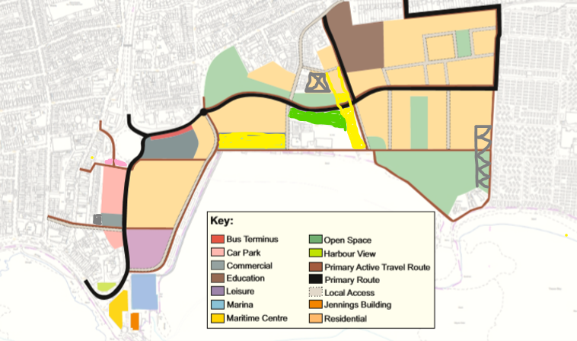
- The ‘brown’ area identified on the plan for education includes the existing Newton Primary School. This is a five-acre site for education, with development land at the rear.

* The education land forms part of the Porthcawl Regeneration Scheme and abuts a proposed highway. Road and infrastructure delivery is not programmed until the end of the regeneration scheme.

1.9 Consequently, the education land site could not realistically be developed until the Porhcawl Regeneration Scheme reaches its final phase.
1.10 As the school site can only be developed once the new road has been constructed as part of the regeneration, school construction works could not commence for a number of years (which would take any construction beyond the Welsh Government Welsh-medium Childcare Grant funding window).
2. Current situation
2.1 A site options scoring workshop has been undertaken, in conjunction with council technical officers, on the two sites identified from initial desktop study with development potential for combined Welsh-medium provision.
2.2 However, subsequent to architects having worked up outline ‘test-fit’ plans, it transpired that the original list of two site options (that is, Porthcawl Primary School and Newton Porthcawl Regeneration land) effectively become a shortlist of one site (that is, Porthcawl Primary School) due to the fact that suitable access cannot currently be achieved at the Newton Porthcawl Regeneration Scheme land site location.
2.3 The access lane to the west of Newton Primary School is extremely narrow. With adjacent land not within the ownership of the local authority, there is currently insufficient room to create the necessary road widening and footway provision that would be required for a new Welsh-medium provision.

Newton (Porthcawl Regeneration Scheme land) site
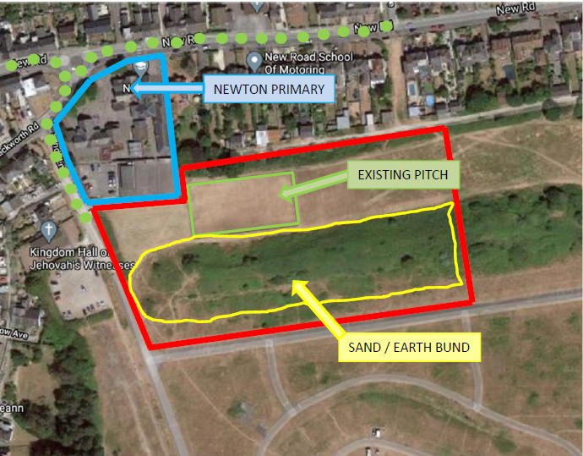
2.4 Local authority technical officers have confirmed that the Porthcawl Primary School site can accommodate a combined Welsh-medium seedling school and Welsh-medium childcare.
Porthcawl Primary School site
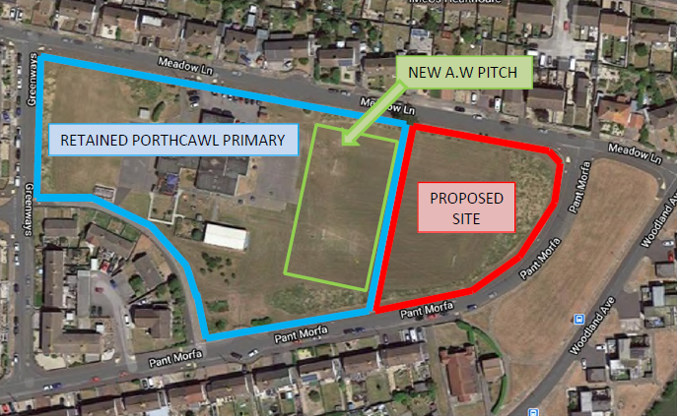
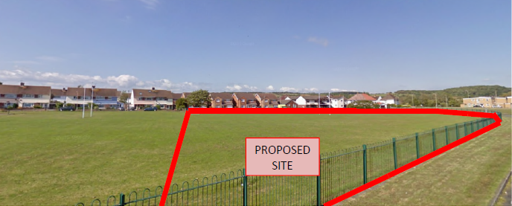

2.5 Porthcawl Primary School is situated relatively central in the Porthcawl area and is served by current highway and footway networks. The site has spare capacity in terms of overall area, which can be maximised if Porthcawl Primary School converts to an all-weather pitch instead of grass.
2.6 This conversion could allow some community use of the pitch outside of school hours. This could generate revenue for the upkeep of the pitch along with promoting engagement between the school and its local community.
2.7 The Porthcawl Primary School land is in BCBC ownership. The land is of an adequate size and some of the highway and footway network has already been upgraded for ‘safe routes to schools’ and ‘learner travel’. There are no ecology issues to mitigate or overcome, the site is level and has adequate drainage. There are no known ground condition issues, and the development of the site will not affect any ongoing Regeneration Scheme strategy for the Porthcawl area.
2.8 BCBC Corporate Landlord Department (Major Projects Team) has provided a total cost calculation for the provision of a combined Welsh-medium seedling school and childcare facility (as presented above) on the Porthcawl Primary School site. A business case ‘expression of interest’ submission for the necessary Welsh-medium capital grant funding has been submitted to Welsh Government and has been approved in principle.
2.9 There is no requirement to consult under the School Organisation Code 2018 (Code) as it does not fall with the requirement to consult under the Code.
3. What the proposal means in practice
3.1 The proposal being put forward is to develop a ‘seedling’ Welsh-medium school (that is, a ‘starter class’ for 30 full-time equivalent nursery pupils plus 30 full-time equivalent Reception pupils) with co-located Welsh-medium childcare to serve the Porthcawl area (to be located in a new building on the Porthcawl Primary School site). The seedling school will be part of Ysgol y Ferch o’r Sgȇr and at year 1 pupils would transfer to that school.

3.2 It is intended that the new provision would be effective from January 2025.

4. Governing body

4.1 The result of the proposal, should it go ahead, would be that the governing body arrangements would remain unchanged (the seedling school would come under Ysgol y Ferch o’r Sgȇr’s governing body).
5. Staffing Issues

5.1 The governing body of Ysgol y Ferch o’r Sgȇr would be responsible for the staffing structure of the seed school. The structure would be determined primarily by the educational needs of the school and the budget available.
5.2 The co-located childcare facility would be managed by a childcare provider.
6. What are the advantages if the proposal goes ahead
6.1 The proposal brings Welsh-medium education provision to Porthcawl to meet demand in that area and helps to increase the numbers learning through the medium of Welsh in line with Welsh Government targets and the WESP.

6.2 Learners and staff would benefit from a brand-new facility. Opportunity for seamless transition and continuity for learners from Welsh-medium childcare setting to Welsh-medium primary school, enhancing their language skills.

6.3 Community provision could be incorporated into new school build with the opportunity for the existing school (Porthcawl Primary School) to benefit from the provision of an all-weather pitch (in compensation for the reduction in ‘surplus’ external space).

6.4 Opportunities for increased collaboration between Welsh-medium and English-medium schools for authentic experiences to further promote the Welsh language.

6.5 A school, which is designed to provide the right learning environment and curriculum opportunities, particularly at the early Foundation Phase.

7. What are the potential disadvantages if the proposal goes ahead?
7.1 Construction would need to be planned to allow the existing primary school to remain functional during the seedling school and childcare build process. During the construction period, the school playing field will be replaced by an all-weather pitch, which would result in the facility not being available for use for a relatively short period of time. Alternative arrangements would need to be put in place for this period.
7.2 Porthcawl Primary School would have reduced surplus external space.
7.3 There is a small risk that some parents will choose to send their children to the nearby English-medium school following their Welsh-medium ‘seedling’ reception year.

8. Impact of the proposals

Outcomes (standards and wellbeing)
8.1 The development is not likely to have any negative impact on school standards or learner wellbeing. It is likely that the improved transition from early years setting to Welsh-medium primary school will have beneficial impact on learners’ linguistic development and on their wellbeing due to the seamless continuity of provision. There are examples across the local authority and across Wales of schools expanding where standards have improved because of increased staff capacity. As part of the Welsh-medium cluster working arrangements it is anticipated that this proposal would increase staff capacity. This suggests that the proposed development will have a positive impact on quality and standards.

Provision (learning experiences, teaching, care support and guidance, and learning environment)
8.2 The quality of teaching in Ysgol y Ferch o’r Sgȇr is good or better. As the lead for this proposal, it is anticipated that the school will draw on its well-developed processes and systems to help ensure the quality of teaching and learning is maintained and to offer effective arrangements to support all learners. This would be supported in the seed school as it will be purpose built and designed to facilitate the principles of foundation phase pedagogies as well as support Curriculum for Wales. The continuity of provision would enhance the teaching and learning experiences and would provide greater care support and guidance for the learners. Therefore, it is likely that experiences for learners would improve with a modern, purpose-built facility as proposed.

Leadership and management (leadership, improving quality, partnership working and resource management)

8.3 Ysgol y Ferch o’r Sgȇr currently has effective leadership and governance. Throughout the pandemic they have been effective at ensuring blended and remote learning was delivered as well as ensuring business continuity as well as supporting many non-Welsh speaking parents with their child’s language development. It is likely that because of the effective leadership and governance, the proposals will not have a significant impact on the how the school is run.

Other considerations
8.4 The admissions authority for the proposed new seedling school would be BCBC. Admission arrangements would be as detailed within the council’s ‘Starting School prospectus – A Guide to BCBC’s Policy and Admission Arrangements for Schools’:

Travel arrangements and accessibility impact

8.5 Learner transport will be in line with BCBC’s Home to School Transport Policy.

9. Next steps

9.1 BCBC is now seeking to solicit views (albeit, not in the formal School Organisation Code manner) on the proposal to establish a ‘seedling’ Welsh-medium provision on the existing Porthcawl Primary School site to serve the Porthcawl area.

9.2 Views are being sought from stakeholders as detailed below:
  - governors of the directly affected schools (Porthcawl Primary School and Ysgol y Ferch o’r Sgêr);
  - staff, learners and parents;
  - ward members;
  - the Welsh in Education Forum members;
  - the public (consultation intended to be live on Council website 27 February 2023);
  - local childcare providers; and
  - Porthcawl Town Council.
9.3 Stakeholders are requested to provide feedback using the form (overleaf) by 10 April 2023. Alternatively, an online questionnaire can be completed on the Council’s website: https://www.bridgend.gov.uk/my-council/consultations/

Proposal for Welsh-medium seedling school and childcare in the Porthcawl area

Feedback form

Proposal to develop a ‘seedling’ Welsh-medium school (that is, a ‘starter class’ for 30 full-time equivalent nursery pupils plus 30 full-time equivalent reception pupils) with co-located Welsh-medium childcare to serve the Porthcawl area (to be located in a new building on the Porthcawl Primary School site).

Name:

Contact details:

Are you
 | a school governor |  | a parent/carer
 | a pupil |  | a member of school staff
 | another interested party (please specify)

Do you support the proposal: Yes or No
If you do not support the proposal – please state why:

Comment/suggestions/requests/questions

If you would like to suggest any changes or alternatives to the proposals presented, please give details:

Any other comments:

We would like to know your views on the effects that the proposals would have on the Welsh language; specifically on opportunities for people to use Welsh and on treating the Welsh language no less favourably than English.
What effects do you think there would be?
How could positive effects be increased, or negative effects be mitigated?

Please also explain how you believe the proposals could be formulated or changed so as to have positive effects or increased positive effects on opportunities for people to use the Welsh language, and on treating the Welsh language no less favourably than the English language and ensure there are no adverse effects on opportunities for people to use the Welsh language.

If you have any further questions regarding this proposal, or would like your views known, please contact:
Education and Family Support Directorate
Bridgend County Borough Council
Civic Offices
Angel Street
Bridgend
CF31 4WB.
edsu@bridgend.gov.uk
(01656) 643643

