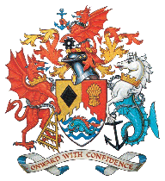 | Mayor's Citizenship Awards 2024 | 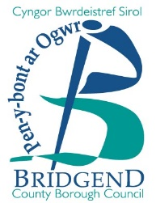

What are they and who are they open to?
The Mayor's Citizenship Awards are the most prestigious annual community awards celebrating exceptional citizens within Bridgend County Borough. Awards are open to all citizens who live or work in the county borough. Nominations must fit the criteria set out in any of the three categories below – individual, group or business.

Nominations open on Monday 6 November 2024

What is the deadline for nominations?
The deadline for nominations is Friday 12 January 2024 and successful nominators will be notified shortly afterwards.

Mayor's Citizenship Awards criteria:
- Nominees can only be eligible for a single award.
- Past winners can only be nominated for a new achievement.
- These awards are open to all citizens. However, those nominated for their paid work must be carrying out exceptional work above and beyond what is expected of their post.
- All awards are equal in value.

Categories | Criteria
Individual | An exceptional individual who has made a big contribution to their community, either through volunteering, charity fundraising, committing an act of bravery, an outstanding achievement, or by helping to put their community on the map in a positive way.
Group | A group (two people or more) who have made a big contribution to their community, either through collective volunteering, charity fundraising, committing an act of bravery, an outstanding achievement, or by helping to put their community on the map in a positive way.
Business | A local business that has made an impact by either working with a community to improve its surroundings or by sponsoring a community facility, team or organisation. Alternatively, the business may have undertaken some outstanding charity fundraising work.

Nomination form for the Mayor's Citizenship Awards 2024
Your name: ______________________________________________________________
Your address: ____________________________________________________________
________________________________________ Postcode: _______________________
Your telephone number: ____________________________________________________

Your email address (if applicable): ____________________________________________

Person / group / business you are nominating: ________________________________
Their address: ____________________________________________________________

_______________________________________ Postcode: ________________________

Their telephone number: ____________________________________________________

Do you know if they have ever received a Citizenship Award (please tick) Yes ____No____
If yes, what year did they receive the award? ____________________________________

Why are you nominating them? (please give as much information as possible, continuing on a separate page if necessary)

Signed: ………………………………………… Date: ……………………………….

Your nomination will be considered and if successful, you and the nominee will be notified in February 2024.

Please sign and return the form by Friday 12 January 2024 to:

Mayor’s Parlour, Mayor’s Citizenship Award Nomination, Bridgend County Borough Council, Civic Offices, Angel Street, Bridgend CF31 4WB

Or email your nomination to: mayor@bridgend.gov.uk with ‘2024 Citizenship Award Nomination’ in the subject line.

For more information, please contact: 01656 643130 / mayor@bridgend.gov.uk

