Strategic Equality Plan
2024 - 2028
[Type a quote from the document or the summary of an interesting point. You can position the text box anywhere in the document. Use the Drawing Tools tab to change the formatting of the pull quote text box.]

This document is also available in Welsh. Should you require this document in an alternative format such as large print or braille please contact us via:
Email: Equalities@bridgend.gov.uk

Introduction and background

Welcome to Bridgend County Borough Council’s fourth Strategic Equality Plan, which is intended to cover the next four years (2024 to 2028).
We are pleased to present this plan which outlines the objectives, actions and targets that we will be undertaking during this period to ensure that equality, equity, and fairness remain firmly at the heart of how the council plans, provides, and delivers important services to the people of Bridgend County Borough.
Our objectives are based on the Equality and Human Rights Commission (EHRC) research “Is Wales Fairer 2018?” which sets out key inequalities in Wales.
The new plan sets out how we will deliver our equalities commitments whilst continuing to be an inclusive and effective organisation that is representative of its community and does not tolerate discrimination of any kind.
Our aim is to deliver good quality services to our residents, while considering their differing needs and ensuring that no one experiences disadvantage or discrimination due to their background or identity.
We recognise that sustained change takes time and cannot be achieved in isolation, this is why we are working in partnership with other public sector organisations in the county borough to strive towards our vision to become a fairer county borough, promoting opportunities for all and making real and tangible differences to the lives of the people in our communities.

By producing this plan, we will meet our statutory Public Sector Equality Duties under the Equality Act 2010 to advance equality, eliminate unlawful discrimination, victimisation, and harassment, and foster good community relations in our employment, policy, procurement, and service delivery functions.

This plan builds on the progress we have made through the previous plans, by nurturing an environment that recognizes and respects the diversity and uniqueness of individuals, regardless of their characteristics or backgrounds.

During 2020-2024, some of the key achievements in terms of delivering our equality objectives included:
- Running regular Hate Crime awareness sessions across the county borough with South Wales Police;
- Developing an Education and Engagement Team by Education and Family Support that provides integrated support for a range of pupils identified by Estyn as vulnerable or potentially vulnerable;
- Halo have secured investment via national lottery to further develop the Feel Good for Life programme offering support for people living with dementia or cognitive impairment in community settings and their carers.
- There is physical wellbeing opportunities, social opportunities and by working with Awen libraries a range of creative and wellbeing support also. There are 4 weekly opportunities having scaled up the sessions and venues.
- BAVO have been working with Alzheimers society to rebuild community led approaches to dementia friendly communities including related training.”

Our Strategic Equality Plan will not be implemented in isolation, it has been developed and will be delivered alongside our Diversity and Equality Policy and Welsh Language Standards which sets out our commitment to achieving a more inclusive and equal future for all.

This plan is also linked to our Corporate Plan 2023-28. We have valued the contributions from everyone who has participated in the development of this plan.

If you would like to become involved and contribute to continuing to review our priorities that will reduce inequalities in Bridgend County Borough, please contact us.

Council Leader Huw David
Chief Executive Mark Shephard

About us

Bridgend County Borough is a diverse and vibrant area with 145,760 residents and over three million annual visitors. As one of the county borough’s largest employers and service providers we recognise our unique role and influential position within the area and the contribution we can make to the development of inclusive and confident communities.
We are committed to the principles of equality, inclusion and diversity working to ensure that this is demonstrated in our service delivery and in our employment practices. Over the next five years, we want to invest in the right things, the things that make the biggest difference and are most valued by you.

Your council's five ways of working:
- Better and more targeted use of resources
- One council, working well together and with partners
- Improving communication, engagement and responsiveness
- Supporting and empowering communities
- Protecting the services that matter to you the most

Your Council’s 7 Wellbeing Objectives
- A County Borough where we protect our most vulnerable
- A County Borough with fair work, skilled, high-quality jobs and thriving towns
- A County Borough with thriving valleys communities
- A County Borough where we help people meet their potential
- A County Borough that is responding to the climate and nature emergency
- A County Borough where people feel valued, heard and part of their community
- A County Borough where we support people to live healthy and happy lives

- The Purpose of the Strategic Equality Plan

The Strategic Equality Plan 2024-2028 has being developed to demonstrate the Council's commitment to meeting the Equality Act 2010 (Statutory Duties) (Wales) Regulations 2011, which came into force on 6 April 2011.

Building on our previous equalities work the Plan will explain to residents, our workforce, elected members and stakeholders how Bridgend County Borough Council will deliver its equalities commitments whilst continuing to be an inclusive and effective organisation that is representative of our community and does not tolerate discrimination of any kind. We will deliver high quality services to our residents, taking into account their different needs while ensuring that no one experiences disadvantage or discrimination due to their background or identity.

Within the Equality Act 2010, public bodies have an additional responsibility to meet the Public Sector Equality Duty. These are outlined below:

Public Sector Equality Duty
The General Duty
When making decisions and delivering services we must have due regard to:
- Eliminating discrimination, harassment, victimisation and any other conduct that is prohibited under the Act.
- Advancing equality of opportunity between persons who share a relevant protected characteristic and persons who do not share it (protected characteristics are explained later in this report).
- Fostering good relations between persons who share a relevant protected characteristic and persons who do not share it.

When thinking about how to advance equality of opportunity between persons who share a relevant protected characteristic and those who don’t, we also need to:

- Remove or minimise disadvantages suffered by persons who share a relevant protected characteristic and are connected to that characteristic.
- Meet the needs of persons who share a relevant protected characteristic that are different from the needs of persons who do not share it.
- Encourage persons who share a relevant protected characteristic to participate in public life or in any other activity in which participation by such persons is disproportionately low.
- We also have to particularly think about how it will tackle prejudice and promote understanding.

The Specific Duties

The Equality Act provides a power to make regulations imposing duties on public bodies to support better performance of the general duty; these are known as the Specific Public Sector Equality Duties and are different in England, Scotland and Wales.

The Specific Duties underpin the General Duty and have been developed around four main principles:
1. Use of evidence
2. Consultation and Involvement
3. Transparency
4. Leadership

The Welsh Government published regulations that introduced the Specific Duties for Wales in March 2011, these set out the actions the Council must take in order to comply and include the following areas:
- Setting Equality Objectives and publishing a Strategic Equality Plan
- Ensuring it engages with people who have an interest in how the Council’s decisions affect them
- Collecting and publishing information relevant to compliance with the General Duty
- Carrying out Equality Impact Assessments and publishing the results if there is a substantial impact on the Council’s identified
- Publish employment monitoring information annually
- Promote knowledge and understanding of the General Duty amongst its employees and use its performance assessment procedures to identify and address the training needs of its employees in relation to the General Duties
- Set a gender pay equality objective where a gender pay difference is identified
- Think about including conditions relevant to the General Duty in its procurement processes.

Who is protected under the Equality Act 2010?
It is against the law to discriminate against someone because of their protected characteristic.

This is the term used in the Equality Act 2010 to identify the types of things that affect how people are treated and can mean people may experience discrimination. The law is designed to protect them, they are:

- age
- disability
- gender reassignment
- marriage and civil partnership
- pregnancy and maternity
- race
- religion or belief
- sex
- sexual orientation

The Well-being of Future Generations (Wales) Act 2015

The Council is committed to embedding the Well-being of Future Generations Act (Wales) 2015 into all its service delivery and activities making sure that when we make decisions we take into account the impact they could have on people living their lives in Wales in the future. The act aims to create a more equal Wales, where everyone has the opportunity to participate, reach their full potential and is able to contribute fully to the economy, will enable Wales to be more prosperous and innovative. The Act has been put in place to make sure that public bodies are doing all they can to contribute to the improvement of the social, economic, environmental and cultural well-being of Wales.

The Act puts in place a sustainable development principle which means that we must ‘act in a manner which seeks to ensure that the needs of the present are met without compromising the ability of future generations to meet their own needs’.

The Act introduces seven long-term well-being goals, puts in place a sustainable development principle. The Act puts in place a duty on the Council as a public body to maximise its contribution to the seven national wellbeing goals a shown below:
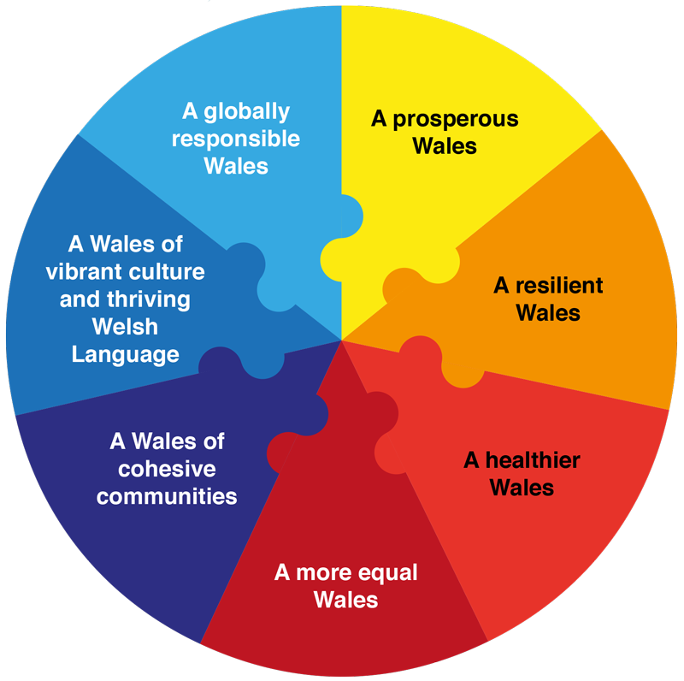

The wellbeing of Future Generations Act asks individual public bodies to apply five ways of working:

Your council's five ways of working:

- Better and more targeted use of resources
- One council, working well together and with partners
- Improving communication, engagement and responsiveness
- Supporting and empowering communities
- protecting the services that matter to you the most

The five ways of working have been used to shape the Council’s equality objectives.

- The information we used to develop our Equality objectives

As well as listening to our residents, communities and our staff we have also used a range of equality information to support us in identifying equality objectives.

We have looked at regional priorities for Bridgend, Council Priorities, Service Delivery plans and their Self Assessments and have reviewed the progress that the Council’s services have already made in relation to the Public Sector Equality Duties.

We have also reviewed national and external sources such as reports by the Equality and Human Rights Commission, Welsh Government policy and priorities, research reports and other relevant statistics.

Whilst a number of external reports and EHRC inquiries have contributed to the development of the Equality Objectives, outlined below is the key report that assisted in shaping the objectives:

Is Wales Fairer? 2018 – Equality and Human Rights Commission (EHRC)

This report addresses seven key challenges that need to be addressed in Wales. The EHRC states there are major, entrenched inequalities and human rights abuses that will require substantial efforts of public, private and third sector organisations and of individuals to reduce them.

This report looks across all areas of life since 2018, including:
- education
- work
- living standards
- health
- justice
- security
- participation in society

This report has acted as a key driver for the development of the Council’s Equality Objectives.

- Our Equality objectives

To develop the equality objectives we have engaged with our residents, stakeholders and our workforce and used relevant information, including EHRC reports, Welsh Government reports and internal strategies.

In addition to this we have:

- Reviewed our Strategic Equality Plan 2020 – 2024 and our action plan for this period and considered our achievements to date;

- Used the council’s corporate plan which outlines the 5 ways of working and also the 7 wellbeing objectives identified to underpin our equality goals.

- Given further consideration to each of the nine protected characteristics covered by the three main aims of the general duty and the requirement to eliminate discrimination, harassment and other actions prohibited in the Equality Act 2010;

- Considered national and local issues such as developing an anti-racist Wales action plan (ARWAP), along with an LGBTQ+ action plan;

- Assessed what we have learnt from regional networks and partnerships such as domestic abuse, violence against men and women, and sexual violence and hate crime;

- Looked at a number of the council’s existing plans and strategies as well as the consultations which took place to inform their development.

- Used feedback that we regularly get from local equality and diversity groups and via the Bridgend Community Cohesion and Equality Forum such as how accessible our services are and how we can help support, promote and raise awareness of issues such as hate crime and LGBTQ History Month;

- Carried out a consultation and engagement exercise with the public, partners and equality and diversity groups. We asked them for their views on the draft objectives for 2024-2028 and asked them to make comments to help us develop our action plan. Throughout the consultation we engaged with 371 people who shared their views with us and we have used these views to help shape our final equalities objectives.

We have set our objectives in line with the findings of the EHRC Is Wales Fairer report and the public consultation. The following overarching objectives have been developed following the consultation to reflect the views of residents and stakeholders from across the county borough:

Access to services

Improve the experience and outcomes for our customers, ensuring that every resident has equity of access to the services that they need.

97.5% of respondents (387) agree with objective 1. Whereas 2.5.% respondents (10) disagree with the objective.

Protecting our most vulnerable

To establish comprehensive policies and procedures that effectively safeguard and support the rights and well-being of our most vulnerable populations, including children, the elderly, people with disabilities, those experiencing homelessness or poverty and those that access care and support from Social Services

95.7% of respondents (381) agree with objective 2. However, 4.3% of respondents (17) disagree with the objective.

Living Standards

To tackle poverty and support independent living by considering the impact of any policy changes or decisions under the socio-economic duty. Consideration to vital services such as Housing and homelessness, cost of living and the effect adverse effects on individuals

95% of respondents agree with Objective 3, and 5% of respondents (20) disagree with the objective.

Participation and Engagement

Encourage people and communities to participate and engage in issues that are important to them and influence the decisions that affect their lives. Building and increasing quality relationships with communities to ensure a maintained focus on what matters to them.

94.2% of respondents (372) agree with objective 4, whereas 5.8% of respondents (23) disagree with the objective.

Learning
To promote equal access to quality learning for all students, regardless of their socioeconomic background, abilities, age or ethnic background. Support diversity, equity, and inclusion.

94.4% of respondents (372) agree with objective 5, whereas 5.6% of respondents 922) disagree with the objective

Employment

Promote a more inclusive workforce and improve the participation, wellbeing, and opportunities for development for those with protected characteristics.

89.9% of respondents agree with objective 6, whereas 10.1% of respondents disagree with the objective.

We will develop an outcome focussed Strategic Equality Plan Action Plan to support this plan which will outline:
- The actions we are seeking to progress under each of our objectives which will make a positive difference to residents and employees’ lives;
- When we expect to achieve these actions;
- Who is responsible for taking the actions forward; and
- How we will measure our success.

Building on the work we have carried out in our previous Strategic Equality Plan, in 2024-2028 we will:

- Continue to work with our partners to provide a range of services for people within our communities;
- Work with the police to identify and tackle hate crime within our communities;
- Strengthen collection and analysis of data for bullying incidents in schools;
- Undertake workplace equality monitoring;
- Ensure our residents can participate in consultations through a variety of formats, including face to face interactions;
- Develop the work of the Citizens’ Panel;
- Review our Equality Impact Assessment processes to include the socio-economic duty.

We will use information that has come from the consultation to support the development of our actions. The action plan will be finalised in the summer of 2024 and added to this plan as appendix one.

- How we will deliver and monitor the Strategic Equality Plan

Successful delivery of our objectives requires strong leadership which is driven primarily by the Future Generations and Well-being Cabinet Member, our Chief Executive and council Leader.

Responsibility for operational delivery rests with all service areas and teams within the authority. Each Corporate Director and Head of Service ensures their employees have the appropriate skills and knowledge of equality that are required. Our Cabinet Equalities Committee monitors delivery against the objectives and scrutinises information available to ensure we identify and implement new strategies and objectives appropriately.

Reports summarising progress against each of the objectives will also be presented to the Cabinet Equalities Committee for consideration.

Our main area of focus in monitoring progress is to undertake further, regular consultation and engagement with all protected characteristic groups. We are mindful that our most reliable measure of success of our equality objectives is via our residents, service users and employees as they use our services and be able to tell us where we have made progress and where we need to continue to improve.

To demonstrate our commitment to meeting our equalities objectives we will:

- Collect and publish relevant equality information
We are committed to collecting data where it is useful and to use that data in an effective manner to identify where some protected characteristic groups may be experiencing a disproportionate impact or where there may be opportunities to deliver services in a different way. We will collect data on customers and residents via our consultation and engagement activities and on our employees via our own internal systems.
We will collect and use the following equality data:
- Employment profile data in respect of all protected characteristics;
- Service user data so that we understand the characteristics of the people who use our services;
- Job applicants in respect of all protected characteristics.

This data will be published annually as part of our Strategic Equality Plan annual reporting process. In addition we will publish annually:
- The Full Equality Impact Assessments undertaken;
- The Strategic Equality Plan action plan review;
- The Strategic Equality Plan annual report.

- Assess the impact or potential impact on protected groups?
We are committed to assessing the impact of new and existing policies, practices and procedures on all equality groups by conducting appropriate equality impact assessments. Our Equality Impact Assessment page is available on the council’s website. When conducting equality impact assessments we will:
- collect and analyse relevant data;
- engage appropriately, through involvement and consultation, with people who are likely to be affected by policies and programmes from the start of the development and planning processes;
- provide our staff with training and support to ensure they carry out robust and meaningful equality impact assessments with confidence and knowledge.

We have also produced an Equality Impact Assessment toolkit which is a practical guide for service managers to use to assess the likely impact of their functions, policies and procedures on different groups of people. In addition to publishing our Equality Impact Assessments we have also published a guide on our website.

- Promote knowledge and understanding of the general and specific duties amongst employees?
Our objectives will include the commitment to continue developing and implementing a comprehensive training and awareness programme for staff in respect of the general and specific duties. We will develop a rolling training programme for the period of this plan.

- Continue to engage throughout the lifetime of this plan
Equality is diverse and we need to include people and their representative groups in our planning and decision making processes to help them unlock their potential. We also need to engage appropriately with people to help us meet our duties in the Public Sector Equality Duty in order to:
- Set future equality objectives;
- Review our Strategic Equality Plan;
- Identify how our work and activities may contribute to meeting the general duty;
- Assess the likely impact on protected groups of our policies and practices being proposed or reviewed.

We recognise that we need specific processes in place to ensure that the needs of people are taken into account. We will continue to use a range of approaches to engage with people, from formal consultation and engagement activities to informal meetings with local groups and individuals.

