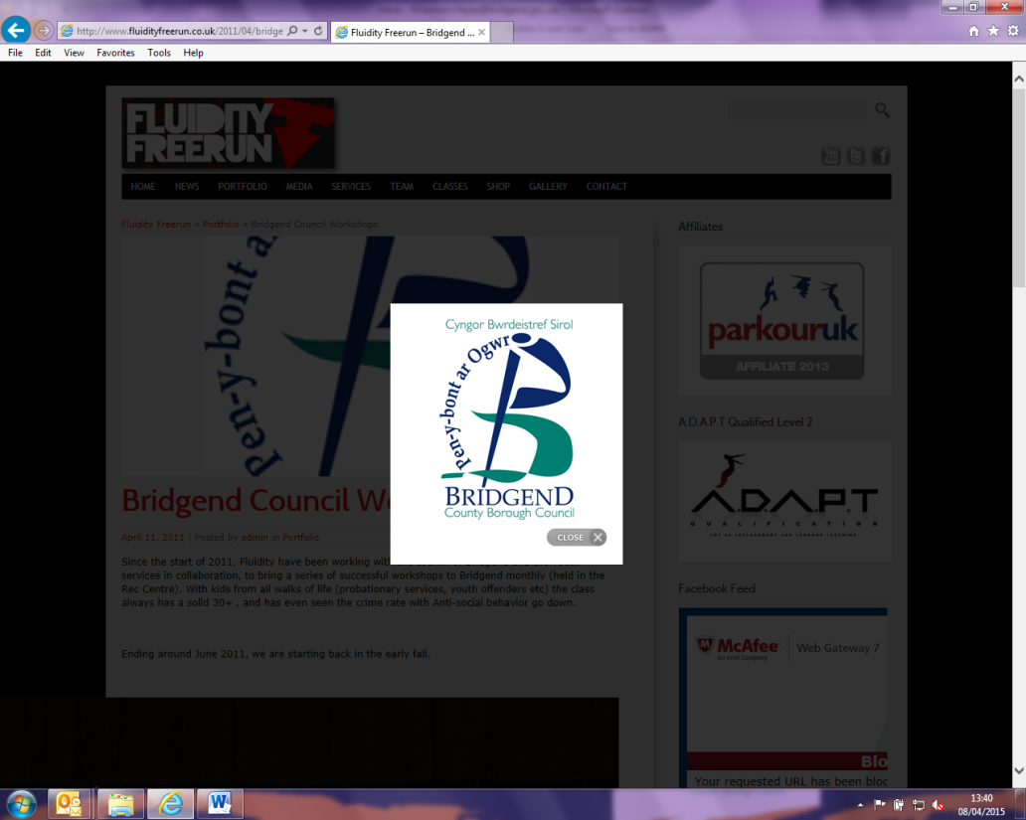

If you require a Welsh language copy of the Request for Help form, or would prefer for the Assessment to be carried out through the medium of Welsh, please contact the Early Help mailbox.

**Is this a Child Protection referral?**

**If so, please send your referral to:**

[mashcentra@bridgend.gov.uk](mailto:mashcentra@bridgend.gov.uk)

[mash@bridgend.gcsx.gov.uk](mailto:mash@bridgend.gcsx.gov.uk)

**Please return the completed form for Early Help to:**

[earlyhelp@bridgend.gov.uk](mailto:earlyhelp@bridgend.gov.uk)

[earlyhelp@bridgend.gcsx.gov.uk](mailto:earlyhelp@bridgend.gcsx.gov.uk)

**Date of Referral:**  Click here to enter a date.

1. **Details of person completing request**

|  |  |
| --- | --- |
| Name: | Email: |
| Agency: | Telephone No: |

1. **Family / Young Person Contact Details**

|  |  |
| --- | --- |
| Home Address |  |
| Telephone numbers |  |

1. **Family Details** – please provide details of all relevant family members

|  |  |  |  |  |  |  |
| --- | --- | --- | --- | --- | --- | --- |
|  | Name | Live in household (Y/N) | Name of Nursery / School / College | Family relationship  e.g. mother, son | Date of birth | M/F |
| **Referred Child 1** |  |  |  |  |  |  |
| **Referred Child 2** |  |  |  |  |  |  |
| **Referred Child 3** |  |  |  |  |  |  |
| Other 1 |  |  |  |  |  |  |
| Other 2 |  |  |  |  |  |  |
| Other 3 |  |  |  |  |  |  |

*(Tab down to increase rows)*

**Is the family currently open to Children’s Safeguarding? Yes/**NO (please delete)

**Is this referral for a Young Carers Assessment? Yes/**NO (please delete)

**Is this a Step Up / Step Down referral?** Yes/NO (please delete & specify)

1. **Why do you consider a Joint Family Assessment or intervention is needed for this child / young person / family?**

|  |
| --- |
| What are the worries for this child / young person / family? What has happened or what have you seen that has made you worried about this child / young person (past and current worries)? |
|  |

|  |
| --- |
| What’s going well for the child / young person? e.g. positive adult relationships (family, school, community), peer friendships, engaged in learning, interests, hopes, ambitions, positive outlook and sense of self, good problem solver, etc. |
|  |

|  |
| --- |
| What additional help do you consider this child / young person / family needs in order to change? |
|  |

**5. Using the Threshold of Need document please indicate the current level of your concern**

|  |  |  |  |
| --- | --- | --- | --- |
| **1. Universal** | **2a. Additional /**  **2b. Vulnerable** | **3. Complex** | **4. Acute** |
|  |  |  | Please follow Child Protection Procedure |

**6. Has the parent / carer consented to this referral being made; or is this a self-referral?**

YES/no (please delete & provide further information if appropriate)

***Early Help services are voluntary, and as such any referral made without consent will not be accepted***

**7. Risk Assessment**

**Are there any known risks relating to any person connected with this referral? Yes/**NO (please delete)

**Is the reason for referral CSE (Child Sexual Exploitation)? Yes/**NO (please delete)

**If the reason for referral is not specifically for CSE, are there CSE concerns? Yes/** NO (please delete)

|  |
| --- |
| If yes to any of the above please provide full details e.g. threats towards staff, history of domestic violence, substance misuse |
|  |