**Draft Strategic Equality Objectives 2020-2024**

**Easy Read**

The consultation **starts** on: 23 December 2019

and will **close** on: 9 February 2020

For further information please visit www.bcbc.gov.uk/SEP where you can find out the detail of the proposals and take part in a survey.

If you require a hard copy of the survey, please get in touch via:

\\tyson\home\BOYCEA\Desktop\New folder\Templates\For front cover\email.PNG[consultation@bridgend.gov.uk](mailto:consultation@bridgend.gov.uk)

\\tyson\home\BOYCEA\Desktop\New folder\Templates\For front cover\phone.PNG01656 643664

\\tyson\home\BOYCEA\Desktop\New folder\Templates\For front cover\write.PNGCivic Offices, Angel Street, Bridgend, CF31 4WB

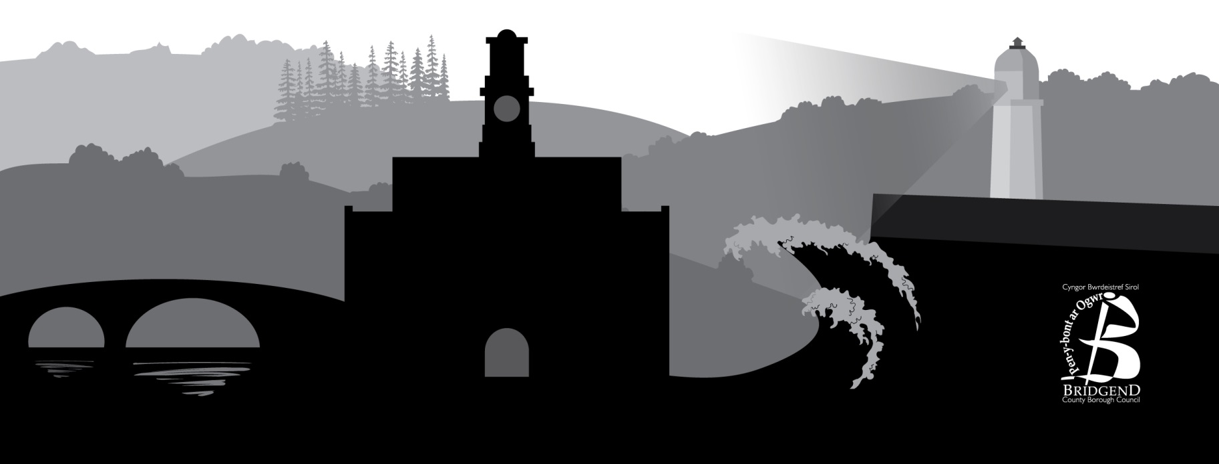

**[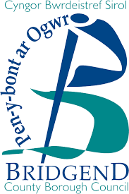](https://www.google.co.uk/url?sa=i&rct=j&q=&esrc=s&source=images&cd=&cad=rja&uact=8&ved=2ahUKEwjwktvDoaHmAhWF2-AKHZ5EDN0QjRx6BAgBEAQ&url=https%3A%2F%2Fwww.bridgend.gov.uk%2F&psig=AOvVaw2aFCfHlPB_oSgtKMihbbnO&ust=1575729918394674)**



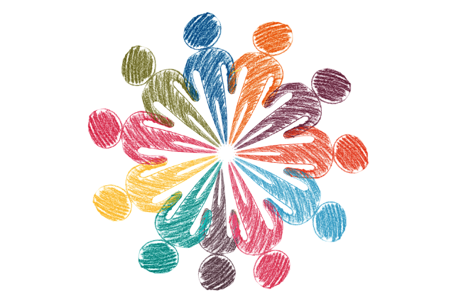Equality is about treating everyone fairly

Everyone should be treated fairly and should feel well, safe and respected

The law says that Bridgend Council must treat all people fairly

To help us make sure everyone is treated fairly we have written some equality objectives.

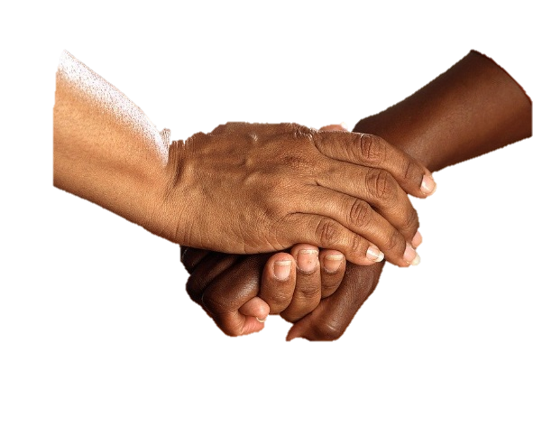

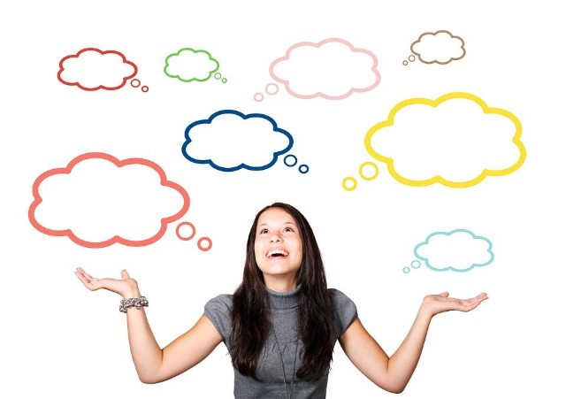

6

An equality objective are the things we want to do by 2024 to make sure people are treated fairly.

We want to know what people think about our equality objectives and plan for the next four years.

We have 6 equality objectives. They are:

* Schools
* Work
* Living well
* Health and wellbeing
* Safety
* Taking part







**Schools**

When children and young people go to school or college, they should be free from bullying and able to be the best that they can be.

*Do you think this equality objective is a good idea?*

* Yes
* No
* Don’t know

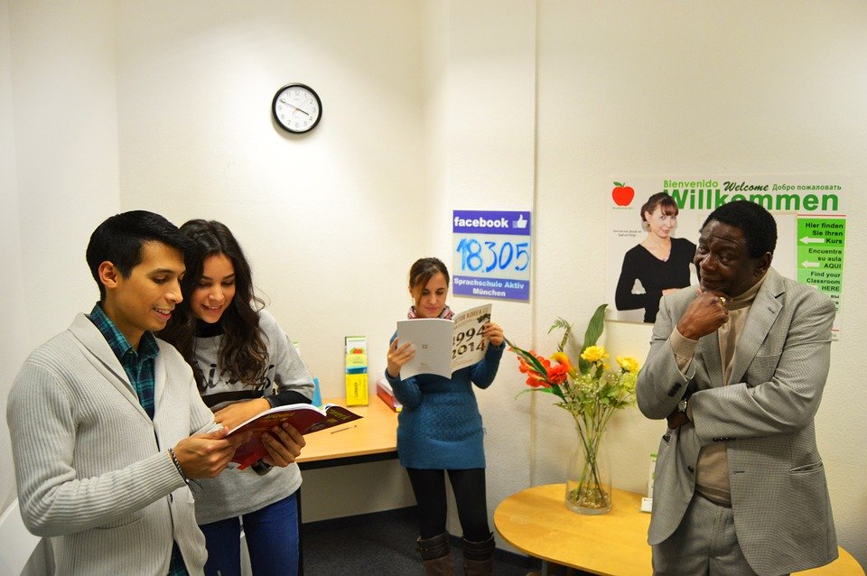





**Work**

When people have a job, they should be paid fairly and there should be more chances for different types of people to work or develop their skills.

*Do you think this equality objective is a good idea?*

* Yes
* No
* Don’t know

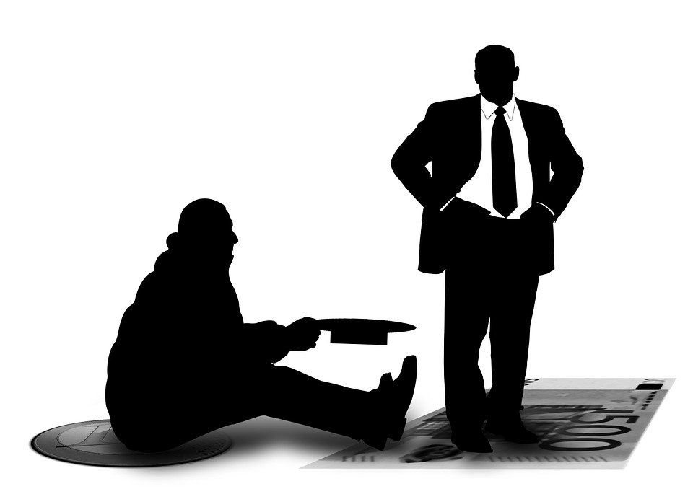





**Living well**

Things should be made fairer for people who are poor and we should think about how the decisions we make will make a difference to them.

*Do you think this equality objective is a good idea?*

* Yes
* No
* Don’t know

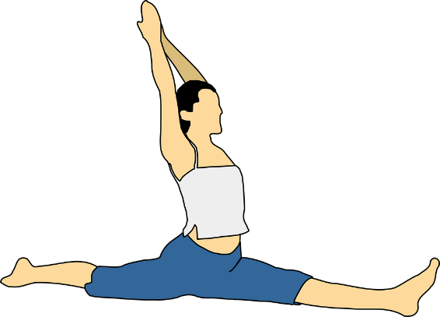





**Health and wellbeing**

People should have happy and healthy bodies and minds and should have chances to get involved in different activities.

*Do you think this equality objective is a good idea?*

* Yes
* No
* Don’t know

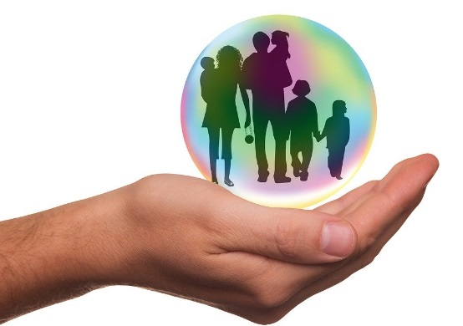





**Safety**

People should feel safe where they live and be treated with respect.

*Do you think this equality objective is a good idea?*

* Yes
* No
* Don’t know







**Taking part**

People should be included when the council are thinking of doing things that will affect their lives.

*Do you think this equality objective is a good idea?*

* Yes
* No
* Don’t know



Is there anything else you want to tell us?









Do you want to know the results of this consultation?

* **Yes**
* **No**

**Email/ Address:**

Please complete the equalities questionnaire.

This helps us know more about the people living in Bridgend.

* **Yes**
* **No**

Do you want to join the Citizens’ Panel?

* **Yes**
* **No**

**Email/ Address:**

**What is this form about?**

|  |  |
| --- | --- |
| A person sitting on a table  Description generated with very high confidence | It is important that everyone is treated the same. |
|  |  |
| A person standing in front of a group of people posing for the camera  Description generated with very high confidence | This form will help us to make sure we are supporting people from all different types of background. |
|  | Your name is not used so information will stay anonymous. |
| A person reading a book  Description generated with high confidence | Please answer any questions you can.  You can ask for help if you need it. |
|  | Please tick any boxes that are right for you. |

**Gender**

Are you Male or Female?

|  |  |  |
| --- | --- | --- |
|  | A person posing for the camera  Description generated with very high confidence |  |
| Male | Female | Prefer not to say |

Are you the same Gender now as when you were born?

|  |  |  |
| --- | --- | --- |
| A person holding a sign  Description generated with high confidence | A picture containing person, man, indoor, wall  Description generated with very high confidence |  |
| Yes | No | Prefer not to say |

Two people sitting at a table with a plate of food

Description generated with very high confidence**Carers**

Are you a **Carer**?

This means you have responsibility for looking after another person.

|  |  |  |
| --- | --- | --- |
| A person holding a sign  Description generated with high confidence | A picture containing person, man, indoor, wall  Description generated with very high confidence |  |
| Yes | No | Prefer not to say |

A person standing in a kitchen

Description generated with high confidence**Pregnancy**

Are you Pregnant?

|  |  |  |
| --- | --- | --- |
| A person holding a sign  Description generated with high confidence | A picture containing person, man, indoor, wall  Description generated with very high confidence |  |
| Yes | No | Prefer not to say |

A picture containing grass, person, little, outdoor

Description generated with very high confidence

Have you had a baby in the last 6 months?

|  |  |  |
| --- | --- | --- |
| A person holding a sign  Description generated with high confidence | A picture containing person, man, indoor, wall  Description generated with very high confidence |  |
| Yes | No | Prefer not to say |

**Sexual Orientation**

What is your sexual orientation?

This means who you are attracted to?

|  |  |  |
| --- | --- | --- |
| A person standing in front of a building  Description generated with very high confidence | A person smiling for the camera  Description generated with very high confidence | A person in a blue shirt  Description generated with high confidence |
| Heterosexual Straight | Gay man | Gay woman Lesbian |

|  |  |  |
| --- | --- | --- |
|  | A picture containing person, wall, man, indoor  Description generated with very high confidence |  |
| Bisexual | Other | Prefer not to say |

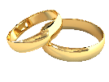**Marital Status**

What is your marital status?

This means who do you spend your life with?

|  |  |  |
| --- | --- | --- |
|  |  |  |
| Single | Partner | Married |
|  | A person standing in front of a building  Description generated with very high confidence | A person looking at the camera  Description generated with very high confidence |
| Civil Partnership | Divorced | Widowed |
|  |  |  |
| Prefer not to say |  |  |

**Ethnic Group**

What is your ethnic group?

This means identifying with a certain race or background.



|  |  |  |
| --- | --- | --- |
| A person smiling for the camera  Description generated with very high confidence |  |  |
|  |  |  |
| White | Mixed ethnic groups | Asian |
|  |  |  |
| Black | A picture containing wall, person, man, indoor  Description generated with very high confidence  Other | Prefer not to say |

|  |
| --- |
| Do you want to say anything else about your ethnicity? |

**Disability**

|  |  |  |
| --- | --- | --- |
|  | What type of disability do you have? |  |
|  | No disability |  |
|  | Physical impairment |  |
|  | Sensory impairment |  |
|  | Mental health condition |  |
|  | Learning disability |  |
|  | Learning difficulty |  |
|  | Long term health condition |  |
|  | Other |  |
|  | Prefer not to say |  |

**Nationality**

What is your Nationality?

This means the country you belong to.

|  |  |  |
| --- | --- | --- |
|  |  |  |
| British | Welsh | Scottish |
|  |  |  |
| Northern Irish | English | Other |
| Prefer not to say |  |  |

**Religion**

What is your Religion or Belief?

|  |  |  |
| --- | --- | --- |
|  |  |  |
| No religion | Christian | Buddhist |
|  |  |  |
| Hindu | Jewish | Muslim |
|  | A picture containing wall, person, man, indoor  Description generated with very high confidence |  |
| Sikh | Other | Prefer not to say |

**Welsh**

Can you speak Welsh?

|  |  |  |
| --- | --- | --- |
|  |  |  |
| Yes | No | Prefer not to say |



Can you read Welsh?

|  |  |  |
| --- | --- | --- |
|  |  |  |
| Yes | No | Prefer not to say |



Can you write Welsh?

|  |  |  |
| --- | --- | --- |
|  |  |  |
| Yes | No | Prefer not to say |