Draft Strategic Equality Objectives 2020-2024
Large Print

The consultation starts on: 23 December 2019

and will close on: 9 February 2020

For further information please visit www.bcbc.gov.uk/SEP where you can find out the detail of the proposals and take part in a survey.

If you require a hard copy of the survey please get in touch via:
consultation@bridgend.gov.uk
01656 643664
Civic Offices, Angel Street, Bridgend, CF31 4WB

Introduction
The Strategic Equality Plan 2020-2024 is being developed to demonstrate the Council's commitment to meeting the Equality Act 2010 (Statutory Duties) (Wales) Regulations 2011, which came into force on 6 April 2011.

The Strategic Equality Plan 2020-2024 is being developed to demonstrate the Council's commitment to meeting the Equality Act 2010 (Statutory Duties) (Wales) Regulations 2011, which came into force on 6 April 2011.

To develop the equality objectives we will engage with residents, staff, elected members and stakeholders and use relevant information, including EHRC reports, Welsh Government reports, internal strategies and the results of staff engagement exercises as well as community groups’ engagement exercises.

We have developed a draft set of Equality Objectives for the Council based on the following overarching themes:

- Education
- Work
- Living standards
- Health and wellbeing
- Safety and respect
- Participation

Education
Everyone who accesses education should be free from discrimination, bullying and abuse in educational settings, in order to narrow the attainment gap and reach their full potential.

Do you agree or disagree that this should be an Equality objective for Bridgend County Borough Council?
- Strongly agree
- Agree
- Neutral
- Disagree
- Strongly disagree

Do you have any comments on this objective?

Work
Address pay gaps to promote a more inclusive workforce and improve the participation and progression for those with protected characteristics.

Do you agree or disagree that this should be an Equality objective for Bridgend County Borough Council?
- Strongly agree
- Agree
- Neutral
- Disagree
- Strongly disagree

Do you have any comments on this objective?

Living standards
Tackle poverty and support independent living by considering the impact of any policy changes or decisions under the socio-economic duty.

Do you agree or disagree that this should be an Equality objective for Bridgend County Borough Council?
- Strongly agree
- Agree
- Neutral
- Disagree
- Strongly disagree

Do you have any comments on this objective?

Health and wellbeing
Support and promote good mental and physical health within our communities and our workforce and provide opportunities to participate in leisure and cultural activities.

Do you agree or disagree that this should be an Equality objective for Bridgend County Borough Council?
- Strongly agree
- Agree
- Neutral
- Disagree
- Strongly disagree

Do you have any comments on this objective?

Safety and respect
Ensure that people within our communities have access to services that support them to live without fear of violence or abuse, and are treated with respect.

Do you agree or disagree that this should be an Equality objective for Bridgend County Borough Council?
- Strongly agree
- Agree
- Neutral
- Disagree
- Strongly disagree

Do you have any comments on this objective?

Participation
Encourage people and communities to participate and engage in issues that are important to them, and influence the decisions that we make.
Do you agree or disagree that this should be an Equality objective for Bridgend County Borough Council?

- Strongly agree
- Agree
- Neutral
- Disagree
- Strongly disagree

Do you have any comments on this objective?

Do you have any other comments about these objectives?

Do you want to be kept up to date with the outcome of the consultation? Please provide your email / address below:
- Opt in
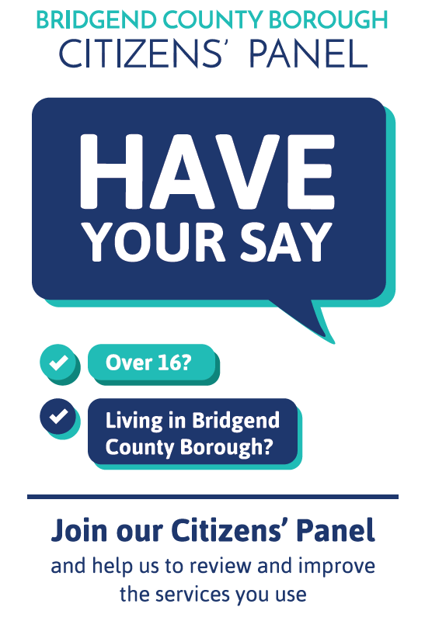

To join the Citizens’ Panel please provide your contact details below:

Equalities monitoring
In order to help us ensure that we are providing services fairly to everyone who needs them, we would be grateful if you could answer a few more questions about yourself.
The information you supply will be kept confidentially and will only be used for the purposes of equalities monitoring.
Completion of these questions is not required as part of the questionnaire. You do not have to answer any of the questions if you do not wish to do so. Alternatively, you can choose to answer some and not others by selecting the 'prefer not to say' options.
Are you happy to answer a few more questions about yourself?

- Yes
- No

Please select your age category. Please select one option only.

- Under 18
- 18 - 24
- 25 - 34
- 35 - 44
- 45 - 54
- 55 - 64
- 65 - 74
- 75+
- Prefer not to say

Do you consider yourself to be disabled? Please select one option only.

- Yes (please type in box below)
- No
- Prefer not to say

Please type in the box below

How would you describe your nationality? Please select one option only.

- Welsh
- English
- Scottish
- Northern Irish
- British
- Other (please type in the box below)
- Prefer not to say

What is your ethnic group? Please select one option only.
- White
- Mixed / multiple ethnic groups
- Asian or Asian British
- Black/African/Caribbean/black British
- Other ethnic group
- Prefer not to say

What is your religion or belief? Please select one option only.

- No religion
- Christian
- Buddhist
- Hindu
- Jewish
- Muslim
- Sikh
- Other (please type in the
- box below)
- Prefer not to say

What is your religion or belief? Please select one option only.

- No religion
- Christian
- Buddhist
- Hindu
- Jewish
- Muslim
- Sikh
- Other (please type in the
- box below)
- Prefer not to say

What is your gender? Please select one option only.

- Male
- Female
- Transgender
- Prefer not to say

Are you pregnant? Please select one option only.

- Yes
- No
- Prefer not to say

Have you given birth within the past 26 weeks? Please select one option only.

- Yes
- No
- Prefer not to say

What is your sexual orientation? Please select one option only.

- Heterosexual / straight
- Gay man
- Gay woman / lesbian
- Bisexual
- Other
- Prefer not to say

What is your marital status? Please select one option only.

- Single
- Partnered
- Married
- Civil partnered
- Divorced
- Widowed
- Prefer not to say

Are you able to...
Please select one option per row.
 | Not at all | A little | Fairly well | Fluently | Prefer not to say
Speak Welsh
Read Welsh
Write Welsh

Thank you

