Draft Strategic Equality Plan Objectives
2020-2024
Consultation document

Easy Read

Date of issue: 23 December 2019
Action required: Responses by 9 February 2020

Tel: (01656) 643 664
Email: consultation@bridgend.gov.uk
Web: www.bridgend.gov.uk/consultation

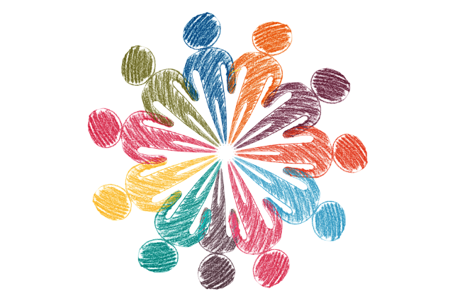

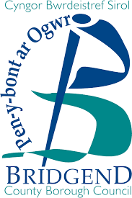

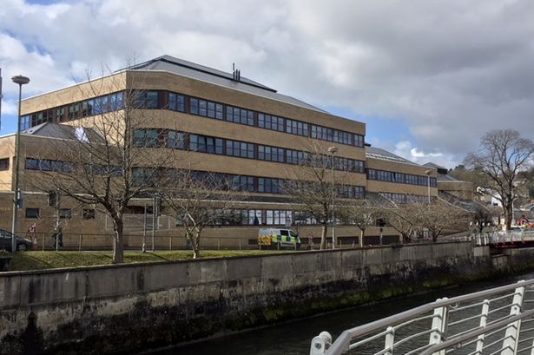

Strategic Equality plan
We want to know what you think about our plan to treat people equally.
Where the document says we, this means Bridgend County Borough Council.
Some words may be hard to understand. These are in bold writing and have been explained in a box beneath the word.

Address: Bridgend County Borough local authority, Civic Offices, Angel Street, Bridgend, CF31 4WB
Email: www.bridgend.gov.uk/consultation

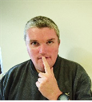

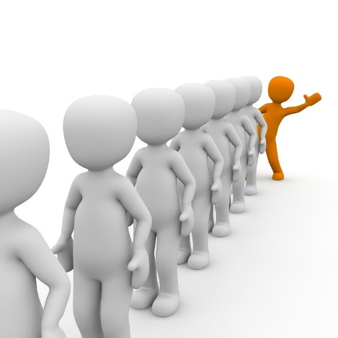

Confidentiality
The information that you give us will be used by the council.
We will follow the rules about keeping your information safe.
If you change your mind about the information you give us, you can ask for it to be deleted.
You can complain about the way your information is used to the data protection officer.

What is a Strategic Equality Plan?
A plan says what will happen
The Council has a Strategic Equality Plan to make sure it does what the law says
Equality is about treating everyone fairly

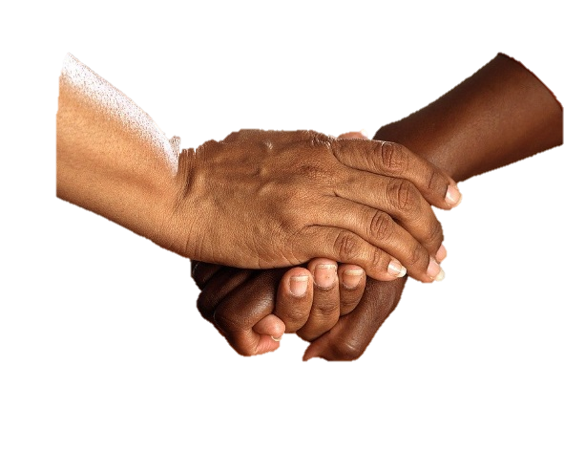

4

Everyone should be treated fairly and should feel well, safe and respected

The law says that Bridgend Council must treat all people fairly

No one should be treated badly or unfairly.

The law says we must check our plan every 4 years.

We want to know what people think about our plan for the next 4 years.

We need to help and support people who are most likely to be treated unfairly.

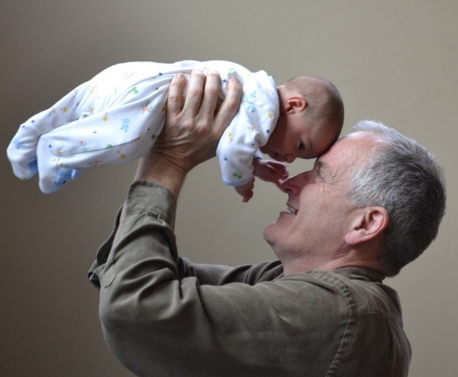

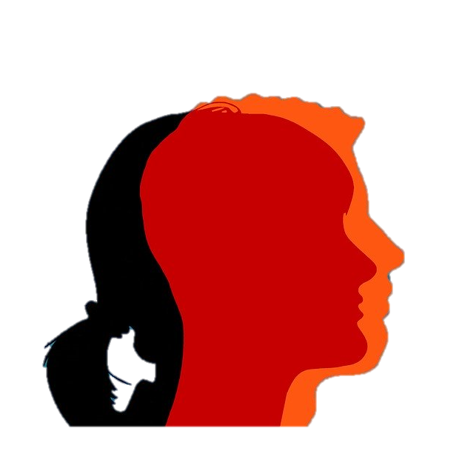

The law says some people have protected characteristic.
No one should be treated unfairly because of:

- People of different ages – younger people or older people

- Transgender people. Transgender people are born as one sex and want to live as the other sex. For example, a person who looks like a man may feel inside like a woman.

- Women who are pregnant or have recently given birth

- People of different religions or who have no religious beliefs

- People who are lesbian, gay men, bisexual people and transgender people.

- Lesbians are women who are attracted to other women

- Gay men are men who are attracted to other men

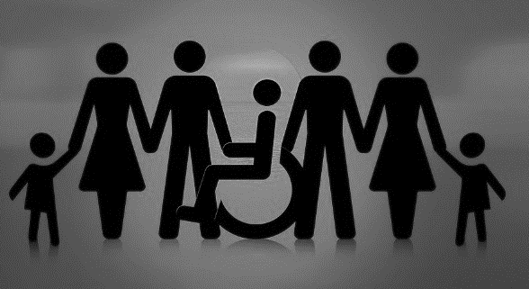
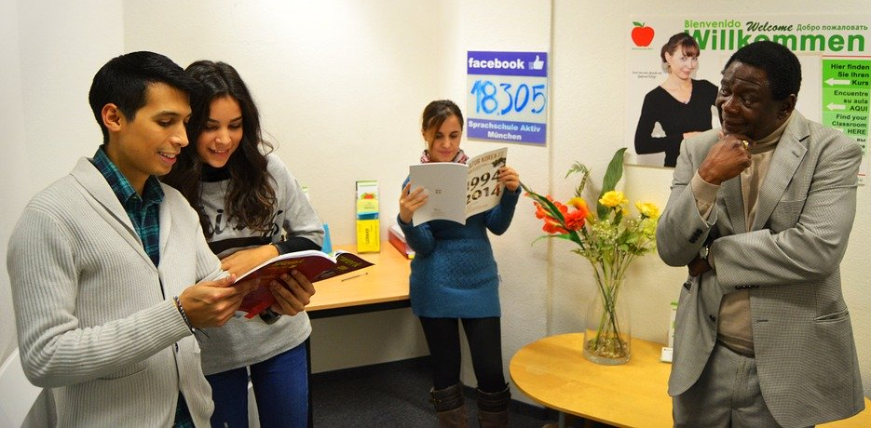

- People who have a disability

- People who are married or in a civil partnership

- People who may live in a different way or have different colour skin

- If they are a man or a woman

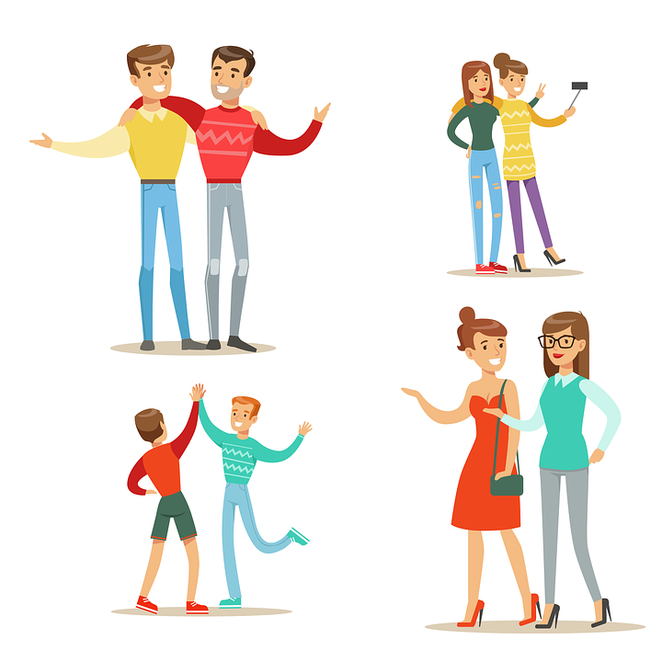

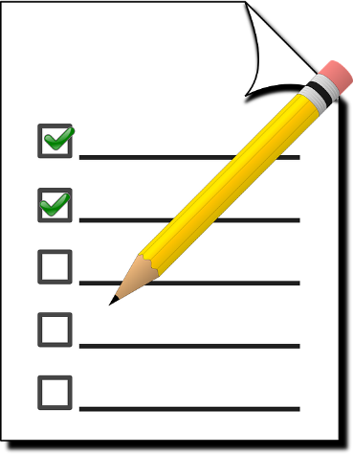

2020

Wellbeing
We want to improve well-being now and for the future for people living in Bridgend.
Well-being means Bridgend is a healthy and fair place to live and people live happy and healthy lives.

What are equality objectives?
To help us make sure everyone is treated fairly we have written some equality objectives.

An equality objective are the things we want to do by 2024 to make sure people are treated fairly.

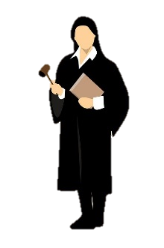

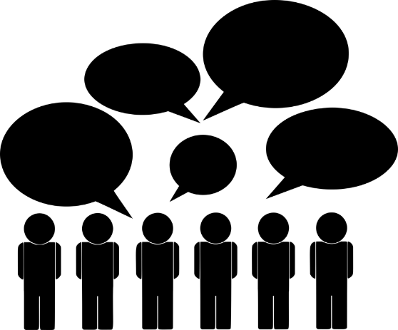

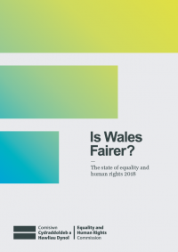

How did you decide your equality objectives?
The law says we must listen to people who are most likely to be treated unfairly.

We will be visiting groups who represent these people.

We want to know what stops them doing things in their lives.

We will also check other organisation and see how fair Wales is.

Our equality objectives
When children and young people go to school or college, they should be free from bullying and able to be the best that they can be.

When people have a job, they should be paid fairly and there should be more chances for different types of people to work or develop their skills.

Things should be made fairer for people who are poor and we should think about how the decisions we make will make a difference to them.

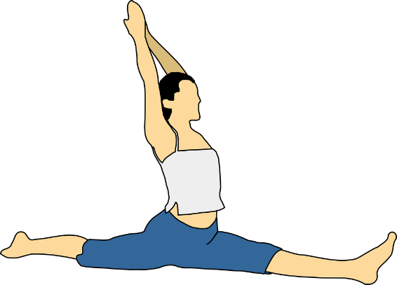

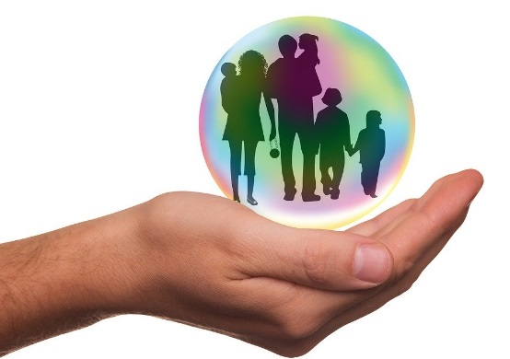

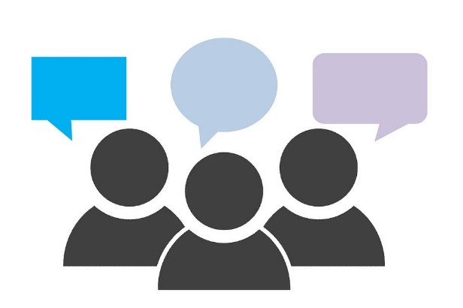

People should have happy and healthy bodies and minds and should have chances to get involved in different activities.

People should feel safe where they live and be treated with respect.

People should be included when the council are thinking of doing things that will affect their lives.

What will happen next?
We want to know what people think about our equality objectives.

We will ask people to do this:
- Online

- Fill in a survey

- Talk to us at events or groups

