APPLICATION FORM

Your name:
Organisation name:
Address:
Postcode:
Tel:
Email:
Web address:

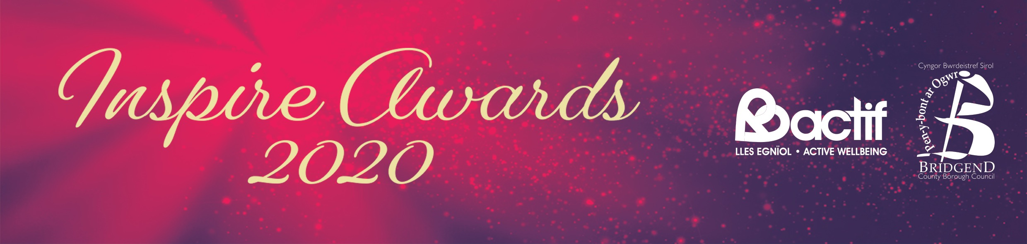
Further Details:
Please note that this section must answer the criteria set out on the Inspired for Life webpage at www.bridgend.gov.uk. Please keep submissions brief, using bullet points where possible.
Name of nominee:
Contact details of nominee:

What was the key issue or opportunity that your nominee attempted to address or improve and what are their most notable achievements?

Please state evidence or information you have of benefits or outcomes achieved between 1 April 2018 and 31 October 2019.

What makes your nomination stand out as good practice or exceptional?

The Inspire Awards 2020 are open to all businesses, partners, individuals and groups based in Bridgend County Borough.
Please return the completed application form no later than 5pm Wednesday 15 January to:

By email: Karen.winch@bridgend.gov.uk

