Background

Bridgend County Borough Council continues to face challenging reductions in funding from central government and we are having to consider changing the way we work, providing more services in partnership and reducing some services in order to manage with less.

In 2015 we had a consultation on reviewing our public conveniences and as a result the number of toilets in our town centres were reduced from nine to six and urinals were de-commissioned. The remaining public conveniences offer disabled facilities and are regularly cleaned and maintained.
It was agreed at a Cabinet meeting on 3 October 2017 that we would undertake a further review of our public toilets service and we would like your views on a range of issues relating to the continued provision of this service.

Your views will then be used to help us make decisions about the future operation and provision of council-owned public conveniences across the county borough.

Current situation

The council currently operates six public conveniences. The toilets are staffed by four toilet attendants who work on a rota system to open, close, and clean the toilets.

The council's Medium Term Financial Strategy (MTFS) proposes to further reduce the budget available to the service which operates public toilets across the county borough.

Bridgend town centre has two public conveniences, Porthcawl town centre has three and Maesteg has one. These are comparable to other town centres where Pontypridd had two public conveniences in the town and Neath has only one.

The current provision in the towns can be described as follows:

Bridgend
Location | Condition | Accessibility | Comments | Operating Times | Attendant Times
Bus Station | Good | Dedicated disabled provision |  | All Year  8.30am –7pm  Mon – Sat  8.30am – 5.30pm Sun | Part time between 9am – 6pm  (12pm to 5pm Sun)
Cheapside (opposite Asda superstore) | Fair | Dedicated disabled provision | Relatively vandal-proof | 9am–6.30pm Mon – Sat  8am – 5pm Sun
Maesteg
Location | Condition | Accessibility | Comments | Operating Times | Attendant Times
Bus station | Good | Dedicated disabled provision | Attached to Maesteg Market | All Year  9am – 6pm Mon-Sat  Sun - Closed | Part time between  10am to 5pm
Free standing toilet |  |  | Operated by Maesteg Town Council
Porthcawl
Location | Condition | Accessibility | Comments | Operating Times | Attendant Times
John Street | Good | Dedicated disabled provision | Grade 2 listed building | Winter  9am – 6pm Mon – Sat  10am – 6pm Sun  Summer  9am – 8pm Mon – Fri  9am – 6pm Sat – Sun | Part time between  9am to 6pm  (10am – 6pm Sun)
Griffin Park | Fair | Dedicated disabled provision |  | Winter  9.30am – 5.30pm Mon – Sat  10.30am – 5.30 Sun  Summer  9.30am – 7.30pm Mon – Fri  9.30am – 5.30pm Sat – Sun | In discussion with Porthcawl Town Council
Rest bay |  | Dedicated disabled  provision |  | Winter  8.30am – 3.30pm  Summer  8.30am – 6pm | In discussion with Porthcawl Town Council

Comfort schemes
As part of its previous review of public toilet provision in the county borough, the council
reintroduced its comfort scheme. This scheme makes small grants (up to £500 per year) available to local businesses, in return for the business opening its toilets to non-paying customers.

This comfort scheme is available borough-wide and makes provision for clean, safe and
accessible public toilets, in convenient locations for residents and visitors in addition to the council-owned facilities.

Introduction

This survey will take around 15 minutes to complete.

All information received is stored using secure servers and in accordance to the Data Protection
Act (1998). When gathering data it is our policy to take all necessary steps to ensure personal
information is processed lawfully. Your personal information will never be shared externally.

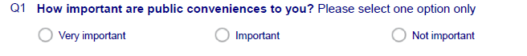
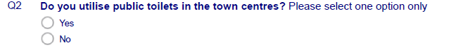
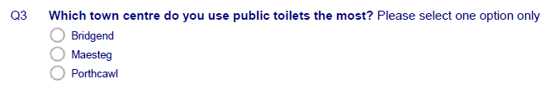
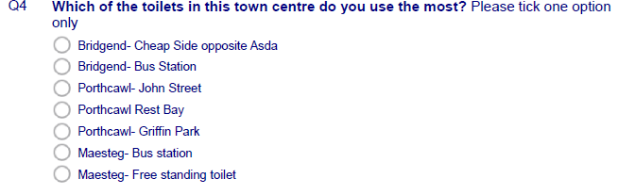
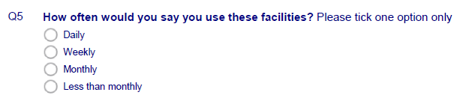

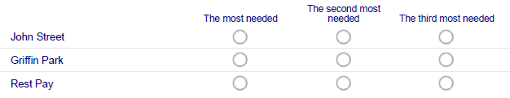

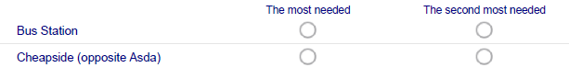
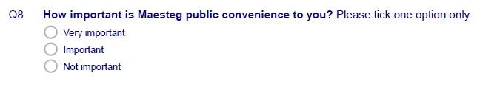

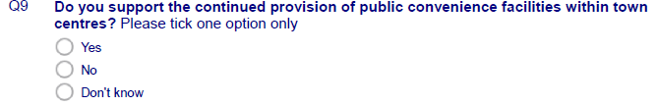
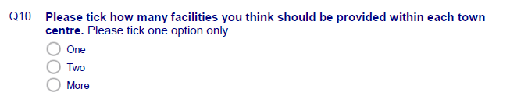
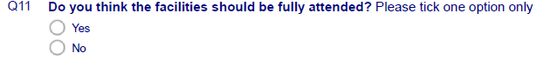
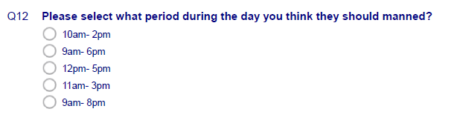
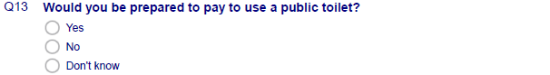

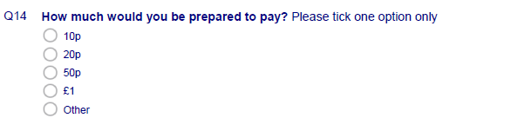

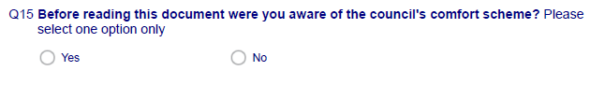
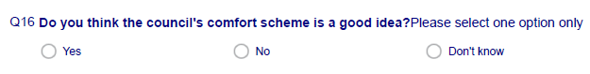
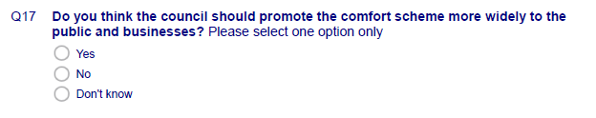
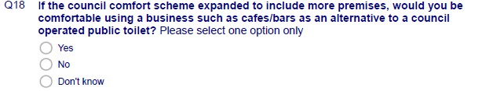

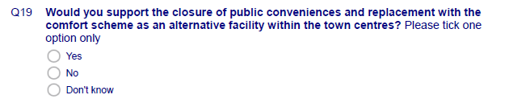

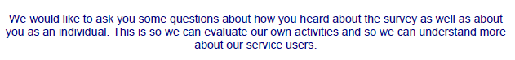
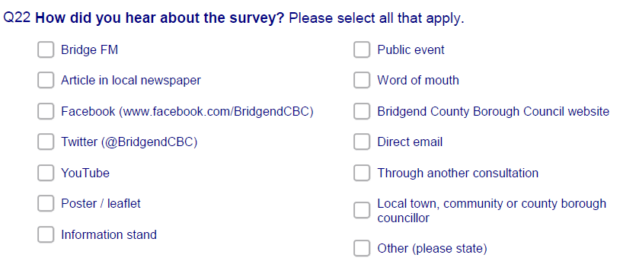

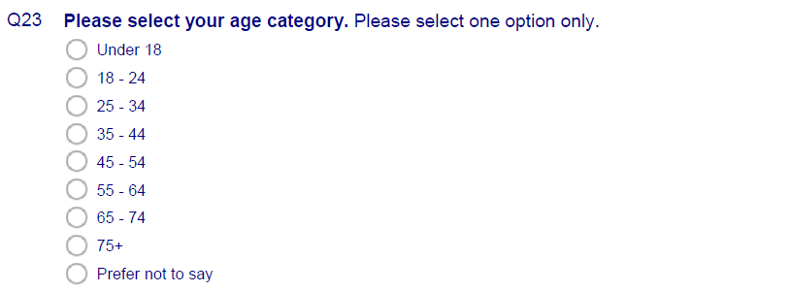

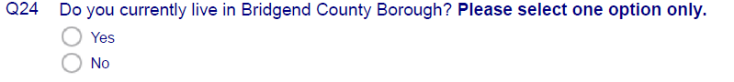

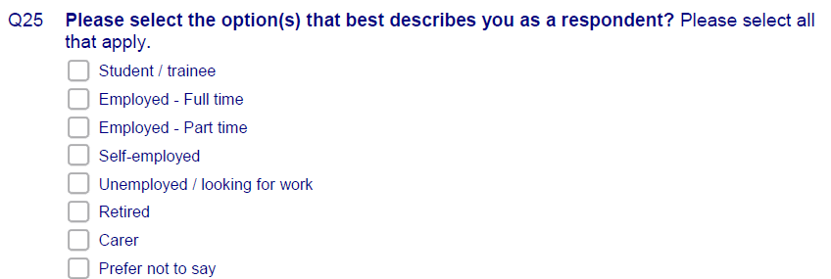
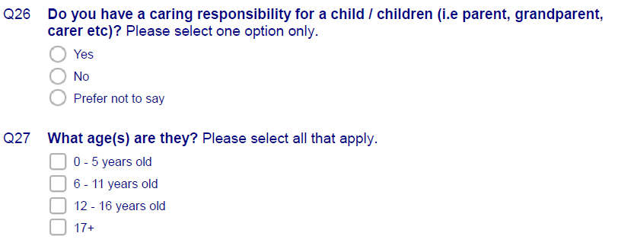

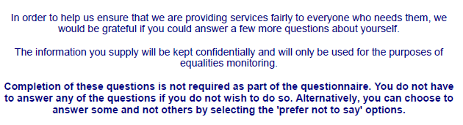
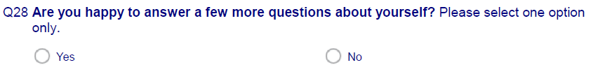
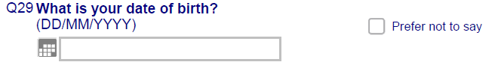
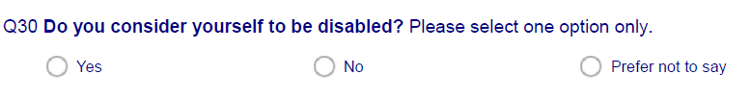
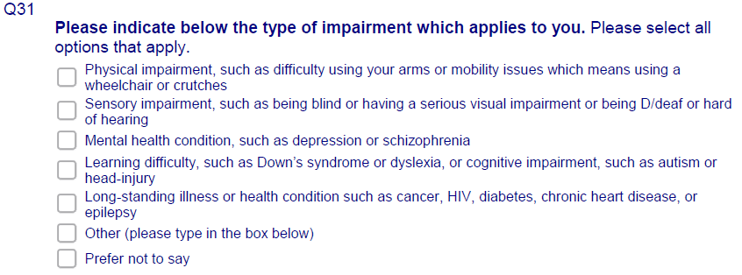
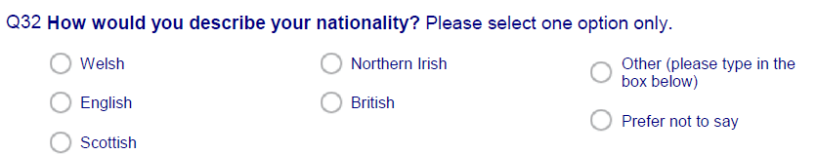
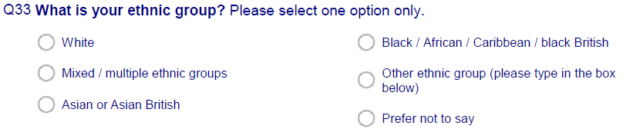

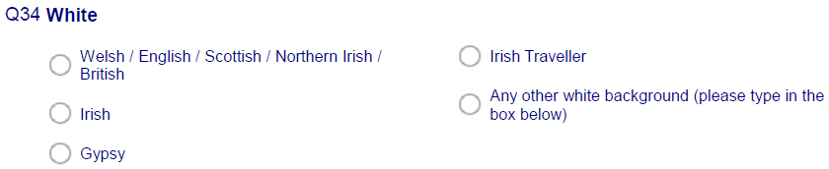

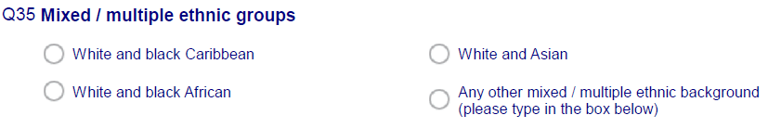

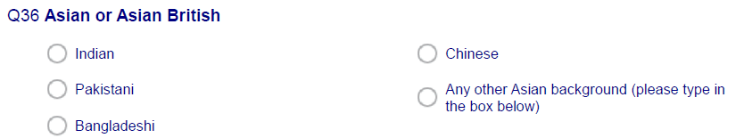

Equalities monitoring
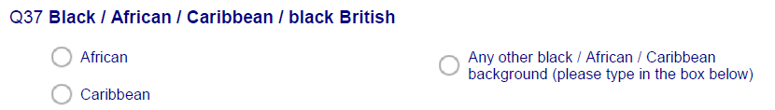

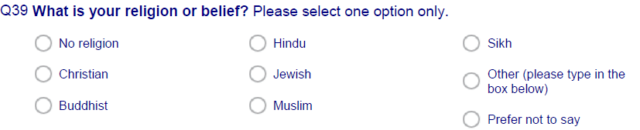

Equalities monitoring

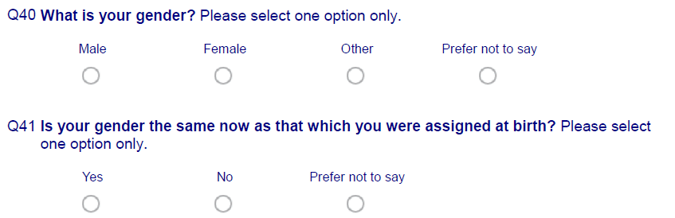
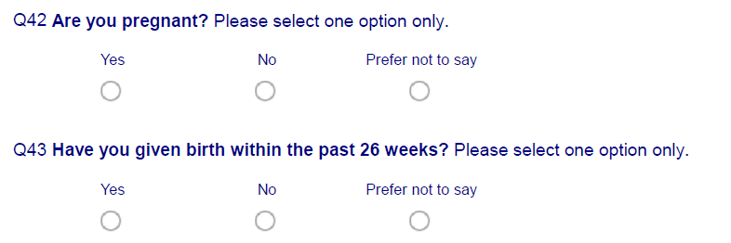
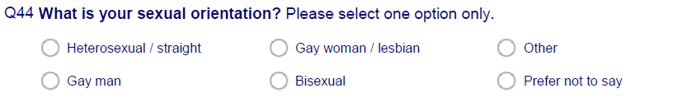
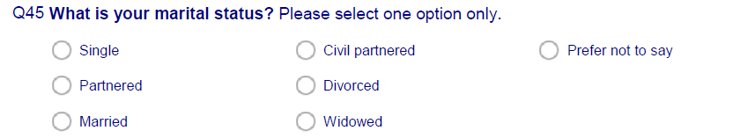

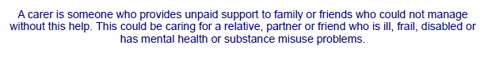
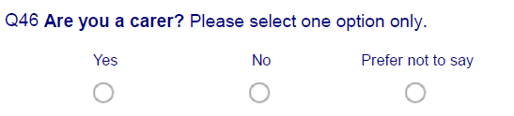
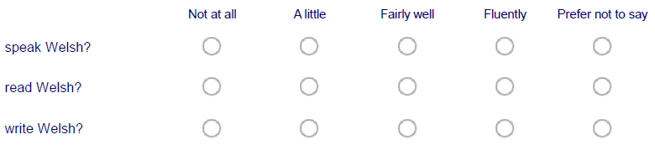

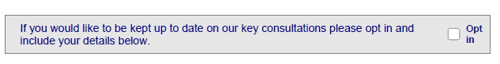

Name

Email

House no.

Street

Postcode

Please return to: Communications, Marketing and Engagement,
Bridgend County Borough Council, Civic Offices, Angel Street, Bridgend CF31 4WB

Remember you can always have your say on improving council services by accessing the below link to join our Citizens’ Panel.
http://www.bridgend.gov.uk/services/consultation/citizens-panel.aspx

