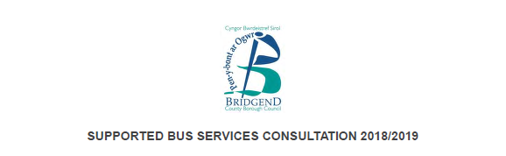

Introduction

This survey will take around 10 minutes to complete.

All information received is stored using secure servers and in accordance
to the Data Protection Act (1998). When gathering data it is our policy to
take all necessary steps to ensure personal information is processed
lawfully. Your personal information will never be shared externally.

Background

This consultation follows a proposal to justify supported bus services across the county borough,
in order to meet a proposed budget reduction of £188,000 in 2018/19, as part of the Council's
Medium Term Financial Strategy.

Bridgend County Borough Council and Welsh Government support some regional and local bus
services by subsidising routes that are not commercially viable. These services operate on routes
to enable residents who live along them to access employment, education, health care and social
activities.

As a result, a Cabinet report was submitted on 03 October 2017, which identified the bus
services for rationalisation, using a methodology adopted from a neighbouring authority and took
into account the following criteria:

- The number of users per journey.
- The subsidy per passenger.
- The unavailability of alternative services.
- The likelihood of related commercial bus service withdrawals.
- The loss of journeys for shift workers.
- The loss of journeys for healthcare and hospital visiting.
- The loss of journeys for education and training.

Proposed changes to bus services can be found here:
