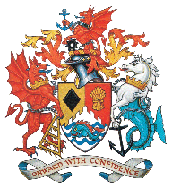 | Mayor's Citizenship Awards 2026 | 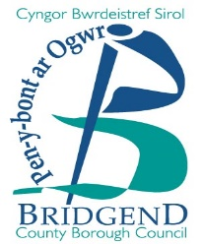

The Mayor's Citizenship Awards are the most prestigious annual community awards celebrating exceptional citizens within Bridgend County Borough. Awards are open to all citizens who live or work in the county borough. Nominations must fit the criteria set out in any of the three categories below – individual, group or business.

Nominations open on Monday 10 November 2025

What are the deadlines for nominations?
The deadline for nominations is Friday 16 January 2026 and successful nominators will be notified shortly afterwards.

Who do I contact for more information?
For more information, please phone 01656 643130 or email mayor@bridgend.gov.uk

Mayor's Citizenship Awards criteria:
- Nominees can only be eligible for a single award.
- Past winners can only be nominated for a new achievement.
- These awards are open to all citizens. However, those nominated for their paid work must be carrying out exceptional work above and beyond what is expected of their post.
- All awards are equal in value.

Categories | Criteria
Individual | An exceptional individual who has made a big contribution to their community, either through volunteering, charity fundraising, committing an act of bravery, an outstanding achievement, or by helping to put their community on the map in a positive way.
Group | A group (two people or more) who have made a big contribution to their community, either through collective volunteering, charity fundraising, committing an act of bravery, an outstanding achievement, or by helping to put their community on the map in a positive way.
Business | A local business that has made an impact by either working with a community to improve its surroundings or by sponsoring a community facility, team or organisation. Alternatively, the business may have undertaken some outstanding charity fundraising work.

Nomination form for the Mayor's Citizenship Awards
Your name: ___________________________________________________________________
Your address: _________________________________________________________________
________________________________________ Postcode: ____________________________
Your telephone number: _________________________________________________________

Your email address (if applicable): _________________________________________________

Person / group / business you are nominating: ________________________________________
Their address: _________________________________________________________________

________________________________________Postcode:_____________________________

Their telephone number: _________________________________________________________

Do you know if they have ever received a Citizenship Award (please tick) Yes ____No____
If yes, what year did they receive the award? _________________________________

Why are you nominating them? (please give as much information as possible, continuing on a separate page if necessary)

Signed……………………………………………….. Date……………………………….

Your nomination will be considered and if successful, you and the nominee will be notified in February 2025.

Please sign and return the form by Friday 16 January 2026 to: Mayor’s Parlour, Mayor’s Citizenship Award Nomination, Bridgend County Borough Council, Civic Offices, Angel Street, Bridgend CF31 4WB

Or email your nomination to: mayor@bridgend.gov.uk with ‘Citizenship Award Nomination 2026’ in the subject line.

