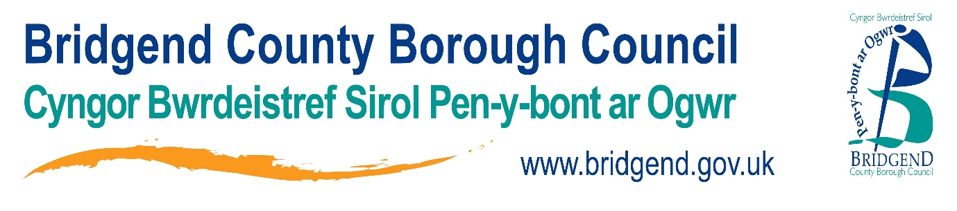

**Strategic Equality Plan**

**Annual Report 2020-21**

**This document is also available in Welsh**

**1. Background** 3

**2. Introduction** 4

**3. Progress in meeting our objectives during 2020/21** 4

**4. Communication, consultation and engagement** 10

**5. Equality Impact Assessments (EIAs)** 11

**6. Procurement arrangements** 11

**7. Employment Information** 11

**8. Employees as at 31 March 2021 by gender and pay grade** 17

**9. Job Applications** 22

**10. Employee Training** 25

**11. Grievance and disciplinary hearings held during 20-21** 28

**12. Employees that left the council in 2020/21** 28

**13. Engagement and consultation** 32

**14. Contact us** 33

**1. Background**

As an authority, our aim is to understand and tackle the equality barriers that people face so that everyone has a fair chance to fulfil their potential. We aim to ensure that equality is a part of everything we do and the services we deliver.

We aim to develop our services and activities in line with the Public Sector Equality Duty (PSED) and the general duties outlined in the Equality Act 2010. This will help us to eliminate unlawful discrimination, advance equality of opportunity and foster good relations.

Our aim is to mainstream equality and diversity, both internally and externally.

Following public consultation, the council’s Strategic Equality Plan 2020-2024 was approved by Cabinet on 10 March 2020, with the following six strategic objectives for 2020-2024:

|  |  |
| --- | --- |
| **Objective** | **What we hope to achieve/support?** |
| **Objective 1:**  **Education** | Everyone who accesses education should be free from discrimination, bullying and abuse in educational settings. |
| **Objective 2:**  **Work** | Promote a more inclusive workforce and improve the participation, wellbeing, and opportunities for development for those with protected characteristics. |
| **Objective 3:**  **Living standards** | Tackle poverty and support independent living by considering the impact of any policy changes or decisions under the socio-economic duty |
| **Objective 4:**  **Health and wellbeing** | Support and promote good mental and physical health within our communities and our workforce and provide opportunities to participate in leisure and cultural activities |
| **Objective 5:**  **Safety and respect** | Ensure that people within our communities have access to services that support them to live without fear of violence or abuse, and to be treated with respect. |
| **Objective 6:**  **Participation** | Encourage people and communities to participate and engage in issues that are important to them and influence the decisions that affect their lives. |

Following this, we worked with a range of key managers across the authority to develop the 58 actions which sit under these six objectives.

We consulted with the public and equality groups on these actions and 647 participants shared their views with us via surveys. Details of this consultation can be viewed [here](https://www.bridgend.gov.uk/my-council/equalities-and-engagement/consultations/closed-consultations/strategic-equality-plan-objectives-2020-to-2024/). Following this, we developed our action plan which was approved by our Cabinet Equalities Committee on 10 March 2020.

Heads of Service and senior service managers are responsible for ensuring the actions are achieved within their service areas. The Communications, Marketing and Engagement team (who are responsible for the equalities agenda) will ensure progress and regular updates are reported at the council’s Cabinet Equalities Committee and that feedback is provided to partners, local equality and diversity groups and other key stakeholders.

**2. Introduction**

This is our first annual report for this strategic annual plan.

In order to prepare this report, we collated data gathered from our annual report of our action plan in July 2021. Data provided at that time by service areas and partners, provide a continual way of monitoring progress against our objectives and actions.

**3. Progress in meeting our objectives during 2020/21**

Key progress under our seven objectives can be summarised as:

**Education**

* The current form for reporting racist incidents is under review, alongside a guidance document. This will be available for the 2021/2022 academic year. Information will be shared with all head teachers in advance of the new academic year. Reports will continue to be shared with Cabinet Committee Equalities on incidents within schools annually. This will help to inform a revised anti-bullying strategy.
* From April 2020 onwards learners have been offered individual digital support in order for them to access online learning provision. In addition to this, all learners are asked to complete individual learning plans which will help to identify any learning needs and determine additional support that can be offered directly by the tutor in addition to any support that can be offered by the wider service. Where learners disclose learning needs these are recorded on a support plan. All courses offered are differentiated to suit a range of learning needs and abilities.
* From April 2020 additional resources have been offered to learners to enable them to access online learning opportunities. Learners have access to devices such as laptops, tablets etc. as well as access to connectivity options. A number of learners have accessed devices in order to take part in courses

**Work**

* Awareness campaigns have focussed on hidden disabilities, hate crime awareness, zero tolerance to hate crime and LGBTQ+/Pride history month. Information is shared internally via the weekly Bridgenders staff bulletin. Wellbeing information for staff focused on resilience and mental health are also promoted via Bridgenders.
* The gender pay gap as at March 2020 and 2021 has been reported which shows a marginal improvement each year. An action plan will be developed in 2021/22.
* BCBC provided apprenticeship opportunities to 34 people in the year 2020/2021. Further opportunities have been explored for graduates and apprenticeships and these will be in place within the next financial year.
* Work is ongoing to promote Disability Confident scheme – Disability Confident Employer badge now visible on the jobs and Equal Opportunities pages of the BCBC website. The Disability Confident Action Plan has been updated and the Disability Confident self-assessment has been undertaken and completed. The Disability Confident Employer badge has been received, which is valid up to 28/11/2023.
* During 2020-21, 2 LGBT courses were delivered with 17 delegates attending.

**Living standards**

* The EIA process has been reviewed. New paperwork has been created and training and guidance documents have been produced. The EIA e-learning has been reviewed to reflect the changes to the process and the implementation of the socio-economic duty.
* New guidance is available on the intranet and webinars have been delivered to ensure officers have access to information about the socio-economic duty. The EIA e-learning module has been reviewed to include socio-economic duty and the new EIA process (The number of E-Learning activities surrounding EIA’s and socio-economic duty is covered later in this report under item 5 for Equality Impact Assessments).
* The Real Living wage was implemented with effect from 1 April 2021 for council employees, which positively impacted on 1,038 employees, of whom 88% were female.
* The provision of food parcels as the local authority's strategy to support pupils eligible for free school meals (eFSM) has been ongoing since Spring 2020. Welsh Government funding continues to financially support the provision of support for eFSM pupils until March 2022.
* During the first lockdown, the Youth Development Service had to ensure that young people in need of free-to-access menstrual products could do so even if they were self-isolating and/or shielding. Linking with colleagues in the Corporate Communications and Marketing team, a social media campaign was started to promote the availability of products to school aged young people. Within the first couple of months the post had reached over 42,000 people resulting in 700 young people receiving home deliveries of products. The campaign continued throughout the second lockdown (December 2020 onwards) and supplies will continue to be offered through the coming summer holidays.

**Health and wellbeing**

* Covid-19 risk assessments have been made available for employees to complete in order to assess their risk. Discussions with managers are encouraged in situations where risks are identified, so that supportive actions can be identified, implemented and reviewed.
* The Health and Wellbeing protocol has been developed, and was launched in October 2020, following consultation with trade union representatives. Staff can access this via the intranet ant the range of other wellbeing resources available. A part time Health and Wellbeing Officer has been appointed who will take the wellbeing agenda forward and ensure all staff are aware of the wellbeing resources and support available.
* In 2020-21, the following courses were delivered in conjunction with Valley Steps and WULF (Wales Union Learning Fund):
* Mindfulness – 4 courses delivered / 37 delegates attended
* Resilience – 4 courses delivered / 45 delegates attended
* Confidence in the Workplace – 4 courses delivered / 38 delegates attended
* Communication in the workplace – 5 courses delivered / 50 delegates attended
  + New approaches were developed with key partners. Super Agers supported people at home and in communities when permitted and chosen as a Bevan Exemplar. Free swimming opportunities have been reviewed in regard to young people with disabilities and also socio-economic disadvantage. Some programmes commenced when venues permitted to open. Additional support for unpaid carers of vulnerable groups created within Halo Leisure. Halo at home digital activities developed including inclusive opportunities. Awen increased availability of digital library resources and home delivery of books etc via the books at home service. Feel good for life programme has supported people living with dementia and cognitive impairment including the development of digital skills and knowledge.
  + New approaches have been developed to remotely support young people with additional needs and families including digital opportunities. The Bridgend Inclusive Network Group (BING) has been supported to bring community groups together to develop collaborative approaches. Work differs to previous years but has expanded the opportunities for many going forward. Partnership working has continued regionally with Disability Sport Wales.
  + Play sufficiency action plan delivered and reported to Welsh Government. Work has included developing a summer play programme for looked after young people and those who are a safeguarding concern. Family Active Zone programme has supplied home activity resources linked to partners identifying socio economic disadvantage of household needs. Digital opportunities developed for young people and households linked to disabled children’s team and also support provided for third sector groups of parent carers to develop their own opportunities and resources. Active young people services have supported schools and community partners with resources to support activity development and wellbeing of young people.
  + The council has raised awareness and promoted campaigns such as autism awareness, the hidden disability lanyard scheme, and mental health awareness. Promotional activities will continue through a calendar of events and awareness days in 2020 to 2022.

**Safety and respect**

* + Work with South Wales Police and local groups continues to ensure any trends and hotspots are monitored and dealt with appropriately. Regular engagement with affected groups and weekly reports are discussed with local hate crime officer.
  + BCBC continue to work with community and equality groups within the Bridgend Community Cohesion Forum (BCCEF), representatives from across the community representing a wide range of organisations meet quarterly to share practice, receive joint briefings and training. All members are invited to share information about BCCEF with other organisations with the aim to increase membership and representation.
  + BCBC marked Holocaust Memorial Day 2020 with a virtual event. The Grand Pavilion and the Civic Offices were lit up purple. The theme for the 2020 event, which is provided by the Holocaust Memorial Trust was ‘Be the light in the darkness’. This theme asks everyone to consider different kinds of ‘darkness’, for example, identity-based persecution, misinformation, denial of justice; and different ways of ‘being the light’, for example, resistance, acts of solidarity, rescue and illuminating mistruths. World Mental Health Day was promoted by lighting the main Civic Offices green, and we have worked in collaboration with Halo to light up the Grand Pavilion to remember the sacrifices made and those we have lost on the anniversary of the first coronavirus lockdown. The council has worked with partner organisations within Bridgend Community Cohesion and Equality Forum to share information on Hate Crime, Dangos launch, BAVO's Black and Minority Ethnic outreach work, barriers that people with sight loss face and the impact of Covid-19, and BCBC's Strategic Equality Plan.
  + BCBC worked with seven other local authorities to promote LGBTQ+ history month by producing and promoting a calendar of events, information, webinars and Q&A sessions. The calendar was promoted on Proud Councils social media accounts and BCBC corporate social media accounts. The Proud Councils - Proud Insights Event was shared with all staff during LGBTQ+ history month. The event saw panel members from Cardiff and Rhondda Cynon Taf Councils coming together to discuss a range of issues, including the importance of LGBTQ+ staff networks in organisations and how these can be developed. There was also the opportunity to take part in a Q&A with panel members to discuss the things that mattered to them. The event which was open to all council employees to attend took place on Friday 26 February 2021.
  + Between December 2020 and April 2021, Small Steps delivered Far Right Extremism Awareness and Counter Narrative Training to 176 members of staff, key partners and community groups.
  + BCBC promoted Black History month on the council’s corporate social media channels. Promoting the Black History Wales Youth Awards, Black Brilliance in Healthcare and the Black History Wales Artists Gallery. BCBC's Youth Mayor made a Black Lives Matter (BLM) video and we coordinated a Hate Crime Awareness Wales (HCAW) webinar with Race Council Cymru on Saturday 10 October, which was attended by the Leader of BCBC who gave a short presentation.
  + To extend the reach of communications across Wales, the council worked closely with regional Violence against women, domestic abuse and sexual violence (VAWDASV) coordinators to fund community communication activities. These activities were aimed at raising awareness of VAWDASV, local services as well as both local and national Live Fear Free campaigns. White Ribbon - Activities were led by survivors of abuse in partnership with specialist services. Events were primarily focused around the 16 Days of Activism and International Day for the Elimination of Violence Against Women and Girls in November and included:
* A survivor-led podcast
* Conferences in South West Wales for victims and professionals
* Development of resources for working with survivors of VAWDASV with additional learning needs
* A community event for young advocates
* Awareness raising and additional training for ‘Healthy Relationship Ambassadors’ in secondary schools.

**Participation**

* Work continues with services to produce easy read and youth versions of consultations where appropriate. During the pandemic corporate social media accounts have been heavily relied on to share information with communities. Explainer videos have also been produced and traditional press releases and radio advertising has been used to share information about key consultations.
* A review of the Citizens Panel has taken place to review demographics and representation across wards within the county borough. An action plan to improve ward representation and increase representation of younger people and people with protected characteristics will be developed for 2021/2022 with an aim to improve the diversity of the panel over the next three years.
* Guidance and training have been developed on producing accessible documents. The guidance is available on the intranet for all staff to access when producing documents for the public.
* BCBC have carried out face to face engagement (online meetings) with Bridgend Community Cohesion and Equality Forum on the BCBC Strategic Equality Plan and Fit for the Future consultation. Details of the Bridgend Town Centre Masterplan consultation were shared with all members of BCCEF via email, and members were asked to share details of the consultation within their own networks.
* BCBC have promoted campaigns via Twitter, Facebook, Instagram and the BCBC website, including:
* Foster care fortnight 2020
* Social care jobs – wecarewales
* Day of reflection
* Woman of Wales event
* LGBT fostering – throughout year
* Youth support
* Hate hurts Wales – hate crime
* Childcare offer
* Give blood
* Community testing
* World autism week
* EU settlement
* ARC mental health – throughout year
* Senedd election
* Register to vote – foreign and 16s citizens
* Early help launch of new website
* Chinese New Year – year of the ox
* International Day for the Elimination of Racial Discrimination
* Welsh in the workplace
* Youth justice launch of new website
* Volunteer week
* International Women’s Day
* Armed Forces day
* Shwmae Sumae day
* World Environment Day
* St Dwynwens Day
* Welsh Language Rights day
* Digital pride
* Hate Crime awareness week 2020,
* Domestic abuse launch of assia
* LGBTQ+ Adoption and Fostering Week
* World Social worker day
* Child Sexual Exploitation
* Young Carers Action Day
* Live fear free from abuse
* Apprenticeship week
* LGBTQ History Month
* National wind rush day
* Show Racism the Red Card workshops (Equalities training for schools)
* World Mental Health Day – Civic offices turn green
* Remembrance day
* Black history month
* Hanukkah
* Diwali
* Iaith gwaith
* International Men’s day
* Carers rights day
* Safeguarding week

**4. Communication, consultation and engagement**

Between 1 April 2020 and 31 March 2021, the council carried out 8 public consultations:

|  |
| --- |
| Town Centre public survey |
| Green and Open Space survey |
| Special Guardianship Orders Financial Policy Consultation |
| Active Travel Consultation |
| Bridgend Town Centre Masterplan |
| Bridgend West Primary Schools Consultation |
| Shaping Bridgend’s Future Consultation 2021 |
| Bridgend transitional foster carer policy |

Citizens’ Panel members were sent the following surveys:

* Bridgend Town Centre Masterplan
* Shaping Bridgend’s Future Consultation 2021

Due to the Covid-19 pandemic, there were no Citizen Panel engagement events undertaken between 1 April 2020 and 31 March 2021.

**5. Equality Impact Assessments (EIAs)**

During the period February 2020 to March 2021, 10 employees completed EIA training via e-learning. To date a total of 266 employees have completed the e-learning module.

**6. Procurement arrangements**

Service areas work with the procurement team to ensure that EIAs are integrated in the procurement process. The contract procedures rules require contracts which are subject to the contract procedure rules to include, as a minimum, clauses relating to equalities and human rights, Welsh language Standards and Modern Slavery. Equality issues are fully integrated into the procurement process from pre-qualification to awarding of contract. The Welsh language standards clause is included in contracts where compliance with the Welsh Language compliance notice is required.

**7. Employment Information**

This report is based on employment information as at 31 March 2021 at which point there were 5929 employees, including those employed in schools.

Steps have been taken each year to improve upon the Equality Monitoring Data we hold for existing employees. This report contains the data, where disclosed, on each of the protected characteristics.

Numbers below 5 in this document have been replaced by * to protect anonymity.

Gender of Total Headcount 31.03.21
4,711 Female
1,218 Male

At present this report does not include any other gender categories as this data is not currently captured. Information within this report is voluntarily provided by employees and percentage figures, reflect the information available as a percentage of the whole workforce.

When comparing data from 31.03.2020 our overall headcount has increased by 105 employees. 73% of these employees were female.

Figure 1 shows the workforce headcount by directorate and schools and the accompanying figure 2 informs the gender breakdown within these.

*Figure 1 – Percentage of Headcount*

*Figure 2 - Gender by Directorate*

The breakdown of the workforce by full and part time working is detailed below and by gender within figure 3. The gender composition has remained fairly consistent over previous years. In comparison with other Local Authorities in Wales (20/21), the council continues to have a higher percentage of female employees. However, it is inevitable that the workforce composition will vary according to the scope of in-house services.

**43% 57%**

of workforce work of workforce work

Full Time Part Time

*Figure 3 – Full/Part Time Split by Gender*

**Disability **

3.36% of our workforce have declared that they have a disability, which represents a small increase from 19/20. 8.20% of the workforce ‘prefer not to say’ and 13.17% have not declared.

The council continues to maintain its Disability Confident status. This scheme supports employers to make the most of the talents disabled people can bring to the workplace and allows us to draw from the widest possible pool of talent, secure and retain high quality employees’ who are skilled, loyal, and hard working. This is promoted on the council’s job pages and at various recruitment campaigns.

The council is also featured on the SCOPE (disability equality charity) website. The recruitment process has also been tested by a small number of individuals with a disability and the council’s application form has been updated from this feedback.

All job related documents are now published in the web accessibility format to enable access to all.

The council has raised awareness of hidden disabilities using corporate social media platforms and promoted internally via Bridgenders.

**Ethnicity**

Figure 4 informs on the percentage of the workforces’ ethnicity background. The ethnicity of the workforce is at 1.6% which in comparison to 19/20 is a small increase. For context, the latest population estimates from StatsWales (June 2021) indicate that 1.5% of the county borough residents are from a Black Asian and Minority Ethnic background.

The council is also one of 900 organisations across Wales who have signed up to the Zero Racism Wales Pledge. Thereby agreeing to take a stand against racism and promote a more inclusive and equal workplace and society that gives every individual in Wales the right to feel safe, valued and included.

The council also worked with seven other local authorities to promote LGBTQ+ history month by producing and promoting a calendar of events, information, webinars and Q&A sessions. The Proud Councils – Proud Insights Event, which took place on the 26th February 2021, was shared with all employees during LGBTQ+ history month and saw panel members coming together to discuss a range of issues, including the importance of LGBTQ+ employee networks in organisations and how these can be developed.

*Figure 4 - % of Workforce Ethnicity*

**Age Profile**

Figure 5 shows the council’s age profile. Compared with 19/20 there have been decreases within the lower age groups (16-35) by 0.91% with the age range of 51-55 staying the same, and the ranges 56-66+ increasing by 1.17%.

Work is being undertaken to encourage applicants from all backgrounds and ages with particular emphasis on promoting careers in Local Government to those leaving education. A new graduate programme, approved in December 2020, has been developed and two graduates are in post.

*Figure 5 - Age Profile*

**Sexuality**

Figure 6 informs most employees have categorised themselves as heterosexual, with 42.6% of the workforce not declaring their sensitive personal information.

*Figure 6 - Sexuality*

**Marital Status**

The marital status of the council’s workforce is detailed in figure 7. Nearly 15% of employee’s marital status is not known with 0.91% preferring not to say. 44.48% of the workforce are married, with 23.39% being single.

*Figure 7 - Marital Status of Workforce*

**Welsh Language**

Table 1 informs on the Welsh Language skills currently within our workforce. To put this into context 4.57% of the council’s workforce stated that they were able to speak Welsh fluently, a further 2.11% stated they could speak Welsh fairly good and 14.81% stated they could speak Welsh a little.

4.60% of the council’s workforce stated that they were able to read Welsh fluently, a further 2.60% stated they could read Welsh fairly good and 15.38% stated they could read Welsh a little.

4.17% of the council’s workforce stated that they were able to write Welsh fluently, a further 2.31% stated they could write Welsh fairly good and 12.75% stated they could write Welsh a little.

New apprentices that are undertaking Business Administration Level 2 / 3 with TSW are now also encouraged to undertake some upskilling in Welsh using Prentis-iath. These courses are for apprentices who currently have little or no Welsh Language skills and enable apprentices to complete part of their qualification in Welsh if they chose. The general course highlights the importance of the Welsh Language as a workplace skill.

*Table 1 - Welsh Language*

|  |  |  |  |  |  |  |  |  |  |  |  |
| --- | --- | --- | --- | --- | --- | --- | --- | --- | --- | --- | --- |
| **Welsh Speaker** | **Female** | **Male** | **Total** | **Welsh Reader** | **Female** | **Male** | **Total** | **Welsh Writer** | **Female** | **Male** | **Total** |
| A little | 700 | 178 | 878 | A little | 736 | 176 | 912 | A little | 626 | 130 | 756 |
| Fairly good | 107 | 18 | 125 | Fairly good | 128 | 26 | 154 | Fairly good | 113 | 24 | 137 |
| Fluent | 231 | 40 | 271 | Fluent | 233 | 40 | 273 | Fluent | 212 | 35 | 247 |

Table 2 shows the percentage of the population within Bridgend County Borough that has the ability to read, write and understand spoken Welsh, according to the Annual Population Survey, for the year ending 30 June 2021, which is a slight increase from December 2020.

Table 2 - Annual Population Survey - Bridgend

|  |  |  |
| --- | --- | --- |
| Read Welsh | Write Welsh | Understand spoken Welsh |
| 17.5% | 16.2% | 22.2% |

**Carers Responsibility**

Figure 8 details the number of employees who have identified that they are carers. 4.78% of the council’s workforce has declared that they have caring responsibilities, however when compared against 19/20 this has slightly reduced.

Figure 8 – Carers

**8. Employees as at 31 March 2021 by gender and pay grade**

The council’s pay and grading structure was implemented on 1 September 2013 and a clear and robust mechanism is in place for evaluating the relative grades of positions. This is based on roles and responsibilities as opposed to any individual factors relating to the employee.

Figure 9 shows the number of employees within the council’s pay and grading structure. When an employee has more than one position they will be counted for each position they hold. As such the figures in the detail below will not correlate with other totals in this report, which are based on headcount.

This is the first time that this level of information has been provided; reporting and further analysis will be developed over time.

*Figure 9 - Employees as per Pay and Grading Structure*

Table 3 details the information by gender.

*Table 3 - Grade by Gender (Pay and Grading Structure as at 31.03.2021)*

|  |  |  |
| --- | --- | --- |
| **Grade** | **Female** | **Male** |
| JE grades 1 – 8 (£17,942 - £25,991) | 4160 | 707 |
| JE grades 9 – 10 (£27,741 - £32,234) | 218 | 98 |
| JE grades 11 – 16 (£33,782 - £52,742) | 325 | 159 |
| JNC Officers (£56,109 - £142,954) | 7 | 10 |
| Soulbury and youth officers (£21,439 - £66,121) | 43 | 8 |
| Teachers, head, deputy, and assistant head teachers (£18,169 - £117,197) | 1048 | 335 |

**Disability**

Figure 10 informs those that have declared they have a disability by grade. It shows that the majority of the disabled workforce are falling within Grades 1-8.

*Figure 10 - Disability by Grade*

**Ethnicity**

Table 4 details the ethnicity of employees by grade. The numbers for Black and Ethnic Minority groups have been collated together due to the figures being low.

*Table 4 - Ethnicity of employees by Grade*

|  |  |  |  |  |  |  |
| --- | --- | --- | --- | --- | --- | --- |
| **Ethnicity** | **Grade 1-8** | **Grade 9-10** | **Grade 11-16** | **JNC Officers** | **Soulbury and Youth Officers** | **Teachers** |
| White | 55.09% | 4.74% | 7.39% | 0.22% | 0.74% | 17.20% |
| Other Ethnic Groups | 1.2% | 0.00% | 0.20% | * | 0.00% | 0.17% |
| Not Declared | 7.30% | 0.35% | 0.24% | * | 0.10% | 4.99% |

**Age Profile**

Table 5 shows the age profile of the council’s workforce by grade.

*Table 5 - Age profile by grade*

|  |  |  |  |  |  |  |
| --- | --- | --- | --- | --- | --- | --- |
| **Age Range** | **Grade 1-8** | **Grade 9-10** | **Grade 11-16** | **JNC Officers** | **Soulbury and Youth Officers** | **Teachers** |
| 16-25 | 3.54% | 0.17% | 0.00% | 0.00% | * | 0.76% |
| 26-35 | 10.56% | 0.81% | 0.93% | 0.00% | 0.24% | 6.19% |
| 36-45 | 13.44% | 1.28% | 2.01% | 0.13% | 0.13% | 7.47% |
| 46-55 | 18.81% | 1.79% | 2.61% | 0.20% | 0.32% | 6.46% |
| 56-65 | 14.91% | 1.05% | 2.14% | * | * | 1.42% |
| 66+ | 2.33% | 0.00% | 0.13% | 0.00% | * | * |

**Sexuality**

Table 6 shows the breakdown of employees by sexual orientation and their grades. Information is held on over 55% of the workforce.

*Table 6 - Sexuality by grade*

|  |  |  |  |  |  |  |
| --- | --- | --- | --- | --- | --- | --- |
| **Sexuality** | **Grade 1-8** | **Grade 9-10** | **Grade 11-16** | **JNC Officers** | **Soulbury and Youth Officers** | **Teachers** |
| Bisexual | 0.34% | * | * | 0.00% | 0.00% | * |
| Gay Man | 0.24% | * | 0.12% | 0.00% | 0.00% | * |
| Gay Woman / Lesbian | 0.19% | * | * | 0.00% | * | * |
| Heterosexual / Straight | 36.18% | 3.59% | 6.21% | 0.19% | 0.57% | 6.86% |
| Other | 0.24% | 0.00% | * | * | 0.00% | 0.00% |
| Prefer not to say | 1.40% | 0.19% | 0.34% | 0.00% | 0.00% | 0.32% |
| Not Declared | 25.01% | 1.25% | 1.06% | * | 0.25% | 14.98% |

**Marital Status**

Table 7 informs the marital status of the council’s workforce by grade, with 85% declaring their marital status.

*Table 7 - Marital Status by Grade*

|  |  |  |  |  |  |  |
| --- | --- | --- | --- | --- | --- | --- |
| **Marital Status** | **Grade 1-8** | **Grade 9-10** | **Grade 11-16** | **JNC Officers** | **Soulbury and Youth Officers** | **Teachers** |
| Married | 1672 | 162 | 279 | 13 | 21 | 494 |
| Partner | 372 | 26 | 42 | * | 7 | 80 |
| Same Sex Civil Partnership | * | 0 | * | 0 | 0 | * |
| Separated / Divorced | 321 | 22 | 47 | 0 | * | 26 |
| Single | 846 | 61 | 69 | * | 14 | 396 |
| Widowed | 42 | * | 6 | 0 | * | * |
| Prefer not to say | 37 | * | 6 | 0 | 0 | 9 |
| Not Stated | 475 | 27 | 13 | * | * | 315 |

**Welsh Language**

With regards to Welsh Language the majority of our Welsh speakers, readers and writers fall within Grades 1-8, in a range of operational roles as demonstrated in table 8.

*Table 8 - Welsh Language per grade*

|  |  |  |  |  |  |  |
| --- | --- | --- | --- | --- | --- | --- |
| **Welsh Speaker** | **Grade 1-8** | **Grade 9-10** | **Grade 11-16** | **JNC Officers** | **Soulbury and Youth Officers** | **Teachers** |
| A little | 533 | 49 | 85 | * | * | 206 |
| Fairly good | 42 | 7 | 10 | * | * | 63 |
| Fluent | 126 | 15 | 21 | 0 | * | 105 |

|  |  |  |  |  |  |  |
| --- | --- | --- | --- | --- | --- | --- |
| **Welsh Reader** | **Grade 1-8** | **Grade 9-10** | **Grade 11-16** | **JNC Officers** | **Soulbury and Youth Officers** | **Teachers** |
| A little | 562 | 51 | 85 | * | 8 | 203 |
| Fairly good | 63 | 6 | 14 | * | * | 69 |
| Fluent | 128 | 14 | 21 | 0 | * | 106 |

|  |  |  |  |  |  |  |
| --- | --- | --- | --- | --- | --- | --- |
| **Welsh Writer** | **Grade 1-8** | **Grade 9-10** | **Grade 11-16** | **JNC Officers** | **Soulbury and Youth Officers** | **Teachers** |
| A little | 447 | 42 | 59 | 0 | 8 | 200 |
| Fairly good | 55 | 7 | 15 | * | 0 | 59 |
| Fluent | 114 | 12 | 15 | 0 | * | 102 |

**Carers Responsibility**

Out of the 283 employees that have confirmed themselves as being carers, 3.15% fall within grades 1-8 as demonstrated in figure 11.

*Figure 11 - Carers by Grade*

**9. Job Applications**

Between 1 April 2020 and 31 March 2021, the council received 4,532 job applications via the HR recruitment system from 3,029 individuals, comprising both internal and external applications. The data does not include applications received directly by some schools. In some instances, applicants did not declare information for each protected characteristic. Where a percentage breakdown has been used this is based on the total number of applicants.

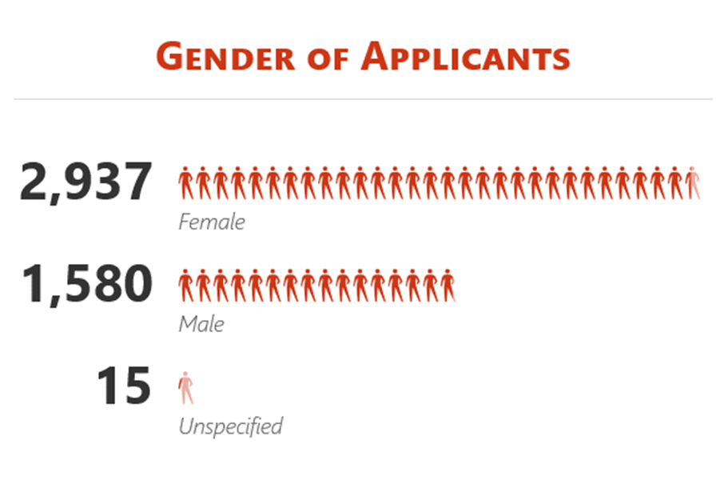

**Disability**

Of the applicants that applied for roles within the council 7.36% identified themselves as having a disability.

**Ethnicity**

Very similar to our workforce in that many applicants (91.85%) inform of their ethnicity being white and a small number (3.47%) either preferring not to say or not declaring their information.

*Figure 12 - Ethnicity of Applicants*

**Age Profile**

Figure 13 demonstrates the applicants age profile.

*Figure 13 – Age profile of Applicants*

**Sexuality**

As with other areas within this report the sexuality of applicants mainly falls within the Heterosexual/Straight category with 6.31% of applicants preferring not to say as the table demonstrates. However, there has been a 100% return on applicants giving this sensitive information.

|  |  |
| --- | --- |
| Heterosexual / Straight | 88.11% |
| Bisexual | 2.34% |
| Gay Man | 1.52% |
| Gay Woman / Lesbian | 0.96% |
| Other | 0.76% |
| Prefer not to say | 6.31% |

*Table 9 - % of Applicants sexuality*

*Figure 14 - Sexuality of Applicants*

**Marital Status**

The highest percent of applicants (39.49%) confirmed they were single, with 3.96% preferring not to say or not completing the required information. This is slightly different in comparison to our workforce where those that are married outnumber those that are single.

*Figure 15 - Marital Status of Applicant*

**Welsh Language**

Table 10 informs the Welsh Language skills of applicants. Out of the 3029 applicants, 6.11% stated they could speak Welsh fluently, a further 3.76% could speak Welsh fairly good and 27.93% stated they could speak Welsh ‘a little’.

Out of the 3029 applicants, 5.35% stated they could read Welsh fluently, a further 3.83% could read Welsh fairly good and 24.27% stated they could read Welsh ‘a little’.

Out of the 3029 applicants, 6.14% stated they could write Welsh fluently, a further 4.79% could write Welsh fairly good and 28.82% stated they could write Welsh ‘a little’.

*Table 10 - Applicants Welsh Language Skills*

|  |  |  |  |  |  |
| --- | --- | --- | --- | --- | --- |
| **Welsh Speaker** | **Applicant** | **Welsh Reader** | **Applicant** | **Welsh Writer** | **Applicant** |
| A little | 846 | A little | 735 | A little | 873 |
| Fairly good | 114 | Fairly good | 116 | Fairly good | 145 |
| Fluent | 185 | Fluent | 162 | Fluent | 186 |

**10. Employee Training**

Due to the Covid-19 Pandemic there was an impact on the delivery of face to face workshops. As a result, for this period, the report focusses on E-Learning training only.

The information below sets out the protected characteristics of those employees who accessed E-Learning between 01 April 2020 and 31 March 2021. During the year, 2252 employees (delegates) attended E-Learning. Where a percentage breakdown has been used this is based on the total number of delegates.

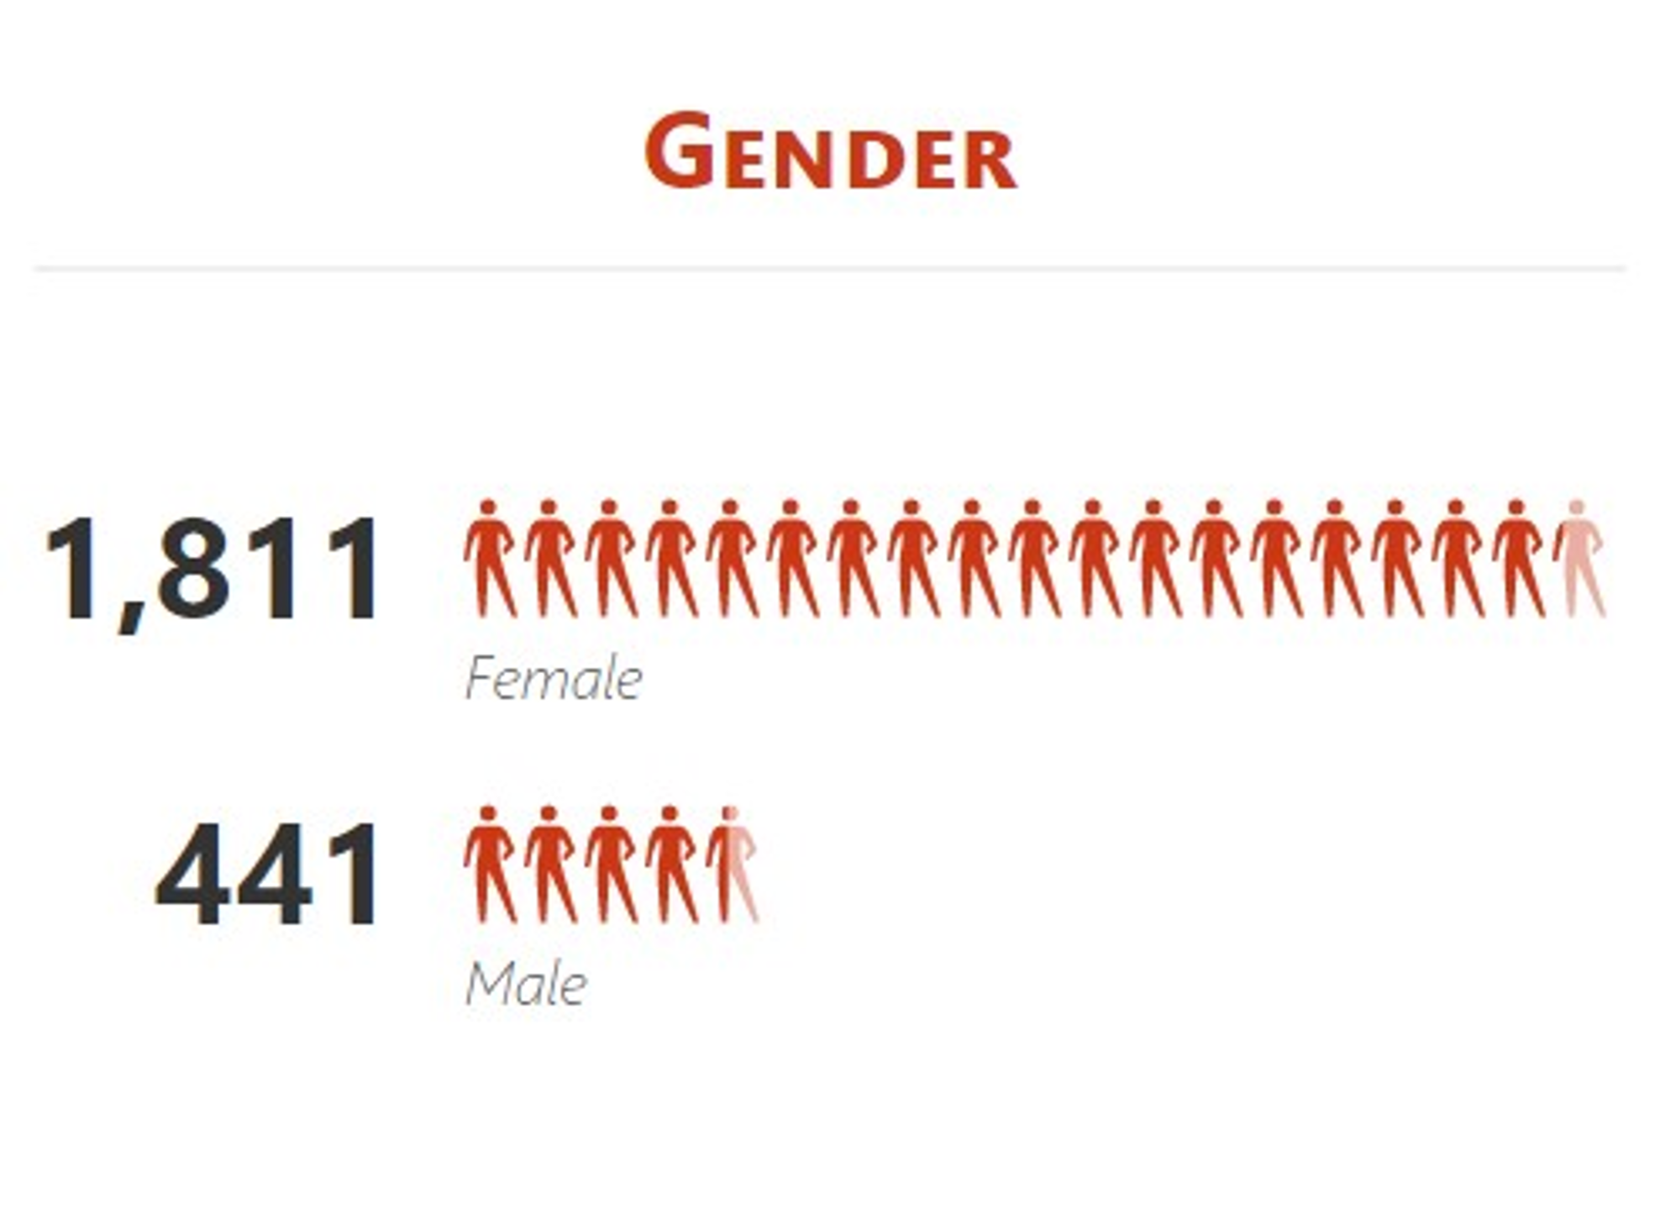

**Disability**

Of the delegates that undertook training 4.53% (102) identified as having a disability, with 7.64% not declaring, 81.3% informing they were not disabled and 6.48% not completing the required information.

**Ethnicity**

The number of delegates who identified as white is a similar percentage to the workforce (85.37%), with a high number (8.39%) not declaring or preferring not to say.

|  |  |
| --- | --- |
| White | 2032 |
| Asian or Asian British | 12 |
| Black or Black British | 6 |
| Mixed Ethnicity | 9 |
| Any other ethnic group | * |
| Prefer not to say | 78 |
| Not Declared | 111 |

*Figure 16 - Ethnicity of Delegates*

*Table 11 – Delegates Ethnicity*

**Age Profile**

The highest percentage of delegates (31.18%) that undertook corporate employee training were in the age range of 46-55. This informs that 39.21% of the workforce within this age range (1790) has undertaken some form of corporate training during this period.

*Figure 17 - Age profile of Delegates*

**Sexuality**

As per the current workforce detail the majority of delegates fall within the Heterosexual/Straight category with a large number of delegates (28.42%) not declaring.

|  |  |
| --- | --- |
| Heterosexual / Straight | 67.63% |
| Bisexual | 0.49% |
| Gay Man | 0.62% |
| Gay Woman / Lesbian | 0.53% |
| Other | * |
| Prefer not to say | 2.18% |
| Not Declared | 28.42% |

*Table 12 –Sexuality of Delegates*

*Figure 18 - Sexuality of Delegates*

Marital Status

As per the workforce the majority of delegates are within the married status, with 9.4% not declaring.

*Figure 19 - Marital Status of Delegate*

**Welsh Language**

Table 13 informs the Welsh Language skills of applicants. Out of the 2252 delegates, 5.15% stated they could speak Welsh fluently, a further 2.09% could speak Welsh fairly good and 20.20% stated they could speak Welsh ‘a little’.

Out of the 2252 delegates, 5.11% stated they could read Welsh fluently, a further 2.93% could read Welsh fairly good and 20.69% stated they could read Welsh ‘a little’.

Out of the 2252 delegates, 4.48% stated they could write Welsh fluently, a further 2.66% could write Welsh fairly good and 16.43% stated they could write Welsh ‘a little’.

*Table 13 - Welsh Language of Delegates*

|  |  |  |  |  |  |
| --- | --- | --- | --- | --- | --- |
| **Welsh Speaker** | **Delegate** | **Welsh Reader** | **Delegate** | **Welsh Writer** | **Delegate** |
| A little | 455 | A little | 466 | A little | 370 |
| Fairly good | 47 | Fairly good | 66 | Fairly good | 60 |
| Fluent | 116 | Fluent | 115 | Fluent | 101 |

**11. Grievance and disciplinary hearings held during 20-21**

This includes employees involved in grievance procedures as a complainant, against whom a complaint was made or subject to a disciplinary procedure. To comply with the data protection requirements, we are unable to disclose this information. In each category, the number of employees and the amount of data is too small for us to interpret in a meaningful way.

**12. Employees that left the council in 2020/21**

The following data summarises the protected characteristics of the 495 individuals who left the employment of the council between 1 April 2020 and 31 March 2021. Data on protected characteristics (other than gender and age) is based upon information disclosed voluntarily by the employees. Where a percentage breakdown has been used this is based on the total number of leavers.

**Gender**

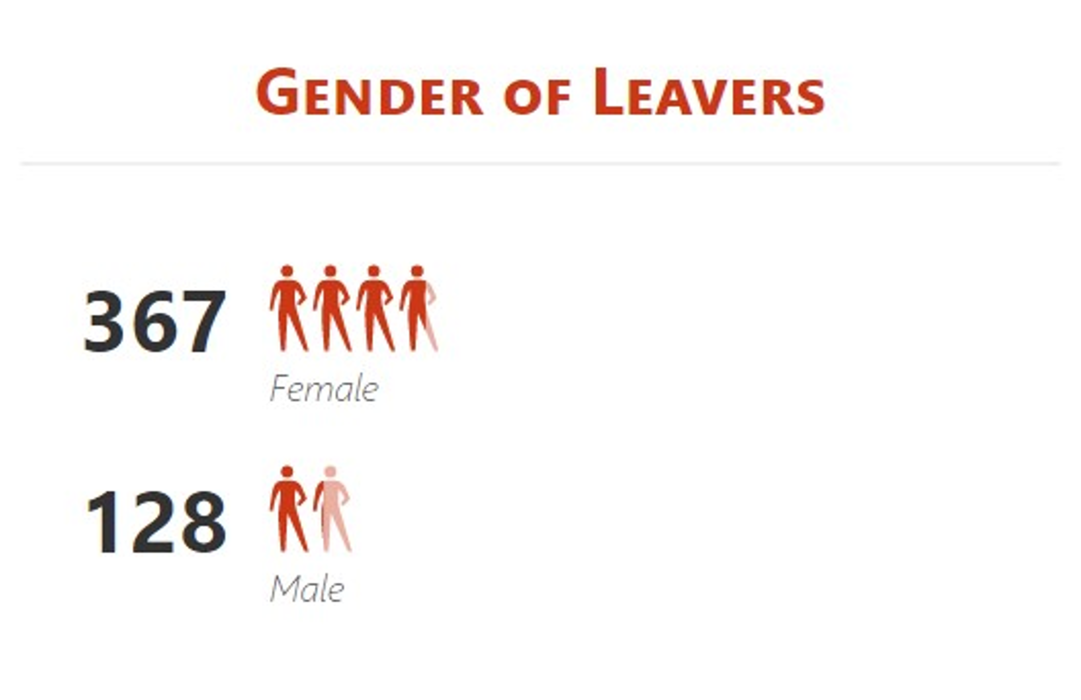

**Disability**

Of the employees that left the council 3.03% (15) identified as having a disability, with 9.29% not declaring, 81.21% informing they were not disabled and 6.46% not completing the required information.

**Ethnicity**

Of those that have left the council, the majority were white, with 1.41% of employees leaving from the Black Asian and Ethnic Minority.

|  |  |
| --- | --- |
| White | 436 |
| Asian or Asian British | * |
| Black or Black British | * |
| Mixed Ethnicity | * |
| Not Declared | 52 |

*Table 14 – Leavers Ethnicity*

*Figure 20 - Ethnicity of Leavers*

**Age Profile**

25.4% of leavers were in the 56-65 year range, of which 47% of those retired, either early or at age – voluntary. 24% of leavers were aged between 26-35 (10% of the workforce within this age range). Of these leavers 57% resigned from the council, and 39% left due to contracts coming to an end.

*Figure 21 - Age profile of Leavers*

**Sexuality**

Like with other areas the vast majority of leavers were within the Heterosexual / Straight category, with 33.13% of employees not declaring their sensitive information.

|  |  |
| --- | --- |
| Heterosexual / Straight | 60.61% |
| Bisexual | * |
| Gay Man | * |
| Gay Woman / Lesbian | * |
| Other | * |
| Prefer not to say | 3.43% |
| Not Declared | 33.13% |

*Table 15 – Leavers Ethnicity*

*Figure 22 - Sexuality of Leavers*

**Marital Status**

The marital status of leavers were in the main married or single with 10% not declaring this protected characteristic.

*Figure 23 - Marital Status of Leavers*

**Welsh Language**

Table 16 informs the Welsh Language skills of applicants. Out of the 495 leavers, 7.68% stated they could speak Welsh fluently, a further 3.43% could speak Welsh fairly good and 14.55% stated they could speak Welsh ‘a little’.

Out of the 495 leavers, 7.74% stated they could read Welsh fluently, a further 3.43% could read Welsh fairly good and 16.16% stated they could read Welsh ‘a little’.

Out of the 495 leavers, 5.66% stated they could write Welsh fluently, a further 4.24% could write Welsh fairly good and 13.13% stated they could write Welsh ‘a little’.

*Table 16 - Welsh Language of Leavers*

|  |  |  |  |  |  |
| --- | --- | --- | --- | --- | --- |
| **Welsh Speaker** | **Leaver** | **Welsh Reader** | **Leaver** | **Welsh Writer** | **Leaver** |
| A little | 72 | A little | 80 | A little | 65 |
| Fairly good | 17 | Fairly good | 17 | Fairly good | 21 |
| Fluent | 38 | Fluent | 37 | Fluent | 28 |

**Carers Responsibility**

The number of carers that left the organisation between 1 April 2020 and 31 March 2021 were 26, 9% of the total amount of carers employed during this period.

*Figure 24 - Carers Responsibility*

**Conclusion**

The council continues to improve its data collection. However, this is dependent on individuals wishing to disclose their identity, which is particularly sensitive around some of the protected characteristics. Employees are offered the opportunity to state ’prefer not to say’ which is useful data in its own right.

With extra promotion for employees to complete their personal and sensitive information via the council’s employee self-service system it is hoped these categories of ‘not declared’ will decrease over the coming years.

**13. Engagement and consultation**

We aim to include the views of representative groups in our planning and decision making processes so we can develop accessible services for the public and our employees.

Engagement is an important part of our work so we put specific processes in place to ensure that people’s needs are taken into account and that the dimensions of equality are addressed.

Employees and stakeholders who represent the protected characteristic groups are involved with the delivery, implementation, monitoring and evaluation of our objectives.

We publish consultation reports on the outcome of our engagement activity to show clearly how people have influenced planning and decision making within Bridgend County Borough Council.

**14. Contact us**

If you would like further information on our SEP or a copy of the plan in an alternative format, please contact us:

By email: [talktous@bridgend.gov.uk](mailto:talktous@bridgend.gov.uk)

By telephone: 01656 643643

By textphone: 18001 01656 643643

By fax: 01656 668126

In writing: Bridgend County Borough Council Civic Offices, Angel Street, Bridgend, CF31 4WB.

Our Customer Contact Centre is open from 8am to 5.30pm, Monday to Friday

This is our complaints procedure.