Bridgend County Borough Council

Pencoed Level Crossing and Penprysg Road Bridge Consultation
Consultation document

Date of issue: 8 November 2021
Action required: Responses by 30 January 2022

Tel: (01656) 643 643
Email: consultation@bridgend.gov.uk
Web: www.bridgend.gov.uk/consultation

www.bridgend.gov.uk

Contents
Overview 3
How to respond 3
Data protection 3
Related documents 4
Background and information 4
The proposal 6
Impact of the proposals 8
Finance 8
The consultation process 8
How to respond 9
Events 9

Overview
This consultation is to invite views on current progress relating to a major capital transport investment to improve multi-modal accessibility within and through Pencoed.

How to respond
This consultation period will begin on Monday 8 November 2021 and will close at 6pm Sunday 30 January 2022.
You can respond or ask further questions in the following ways:
Tel: (01656) 643 643
Email: consultation@bridgend.gov.uk
Online: https://www.bridgend.gov.uk/my-council/equalities-and-engagement/consultations/
Post: Communications, Marketing and Engagement, Bridgend County Borough Council, Civic Offices, Angel Street, Bridgend, CF31 4WB.
Alternative formats are also available upon request.

Data protection
Information provided by you on this form will be used to inform Pencoed Road Bridge and Level Crossing project.

The council will take all reasonable precautions to ensure confidentiality and to comply with data protection legislation. Your information may be shared with relevant service areas for the purposes of future policy development. Your information will be retained in accordance with the council’s Data Retention Policy.
You have a number of rights under data protection legislation. You may also withdraw your consent and ask us to delete your personal information at any time by contacting us. Further information about this is available on our website or you may contact the Data Protection Officer.
If you are dissatisfied with the manner in which we process your personal data then you have the option to make a complaint to the Data Protection Officer and the Information Commissioner’s Office.

Related documents
Redstart: Pencoed – Improving Community Connectivity (WelTAG Stages One and Two Report) (August 2020)

Local Development Plan Background Paper – Land West of Railway Line

For more information on consultations in Bridgend County Borough or how to join our Citizens’ panel.

Visit: www.bridgend.gov.uk/consultation

For more information on active travel routes within Bridgend
Visit:
https://www.bridgend.gov.uk/residents/roads-transport-and-parking/active-travel-routes/

Background and information
Within Pencoed, the main railway line between Cardiff and Swansea divides the community between east and west, with a level crossing at Hendre Road and a road over rail bridge at Penprysg Road, to the north of the level crossing.

Over the decades the number of vehicles on our roads has increased, and with more rail services using the network – the town is affected by significant traffic congestion when the barriers of the crossing are closed to allow trains to safely pass. Penprysg Road bridge, also causes congestion – with traffic signals restricting flow to allow for one-way passage over the bridge in either direction.

Queues of traffic generate emissions which affect air quality, and those who live and work nearby are also affected by noise from idling traffic. Opportunities to walk and cycle - known as active travel - are also limited due to the lack of appropriate connections between the west and east of the town. Traffic movement in general and traffic congestion in particular generates external costs imposed by poor air quality and environmental pollution. Slow moving traffic and idling engines generate pollutants that can cause respiratory problems for residents and visitors in the area. Therefore a scheme such as this that will improve traffic flow and reduce traffic congestion can only improve the air quality in Pencoed.

This congestion problem is long-standing and has led to a moratorium - or pause - on development to the west of the crossing - as identified in Policy PLA6 of the Bridgend Local Development Plan (2006 – 2021). This is a significant constraint on the future economic development and regeneration in Pencoed – preventing the town from reaching its full potential as a place to live and work.

Bridgend Council have carried out a study, working with Network Rail and other partners, to try and find a long-term solution to this problem.

This is known as a WelTAG study. WelTAG is the Welsh Transport Appraisal Guidance. WelTAG is a framework for thinking about proposed changes to the transport system

The WelTAG study considered:

- Congestion – The highway network within Pencoed is under strain at peak travel periods due to the constraints of the two main routes across the railway in the town. Significant delays are experienced at the level crossing on Hendre Road when the barrier is down to allow rail services to safely pass. This leads to queues forming on the highway approaches. Penprysg Road Bridge, to the north of the level crossing, also causes traffic queuing with traffic signals restricting flow to allow for one-way passage over the bridge in either direction. Both routes over the railway are subject to significant additional demand at peak travel times.

- Severance – The railway divides Pencoed town centre and the communities to the east and west. This makes journeys between west and east Pencoed unpredictable – especially at peak travel times. This division has a negative impact on the wellbeing of the community and creates a poor impression of Pencoed for visitors and those living and working in the area.

- Active Travel – Active travel opportunities are currently restricted due to the limited availability of highway space for shared / segregated travel on the network. The current footbridge at the station does not incorporate ramped access – restricting access for people with reduced mobility.

- Restriction on economic development – The planning moratorium west of the railway means that, without significant improvements to travel connectivity, the town will be unable to grow sustainably and benefit from economic and social development.

- Public transport efficiency - The congestion in Pencoed means that buses are unable to achieve reliable journey times. This also makes accessing rail network by public transport more difficult.

- Future increases in rail services – the Welsh and UK Governments have aspirations to increase the frequency rail services west of Cardiff in future. This would increase the amount of time the level crossing barriers are closed – exacerbating the current congestion and its wider impact on Pencoed.

A WelTAG Stage One study was completed in June 2019. This identified, developed and appraised a long-list of options. The process identified which of those options from the long-list should be progressed and further investigated at WelTAG Stage Two.

The subsequent WelTAG Stage Two study was carried out in August 2020. In accordance with the Welsh Transport Appraisal Guidance (WelTAG 2017), the purpose of Stage Two is to examine in greater detail the short-list of options for tackling the problem under consideration, as agreed by the WelTAG Stage One report.

The recommendation of The WelTAG Stage Two study was for the option containing a combination of new bridge provision and closure of the level crossing to be taken forward to WelTAG Stage Three. The closure of the level crossing would be anticipated to include provision of a new active travel bridge.

A Stakeholder Steering Group has been established, including the council, Ogmore MP and constituency MS, the town council and Network Rail. Representatives of the UK and Welsh Governments have also engaged with the Group. Local councillors and other elected representatives have been kept up to date on the project at regular intervals.

The proposal
The WelTAG Stage Two study concluded that a combination of two options should be progressed to WelTAG Stage Three.

This would see the provision of a new active travel bridge over the railway, adjacent to the station, and the permanent closure of the level crossing. The bridge would be fully accessible and compliant with the Equality Act.

An artist’s impression of the new active travel bridge: (option 1)
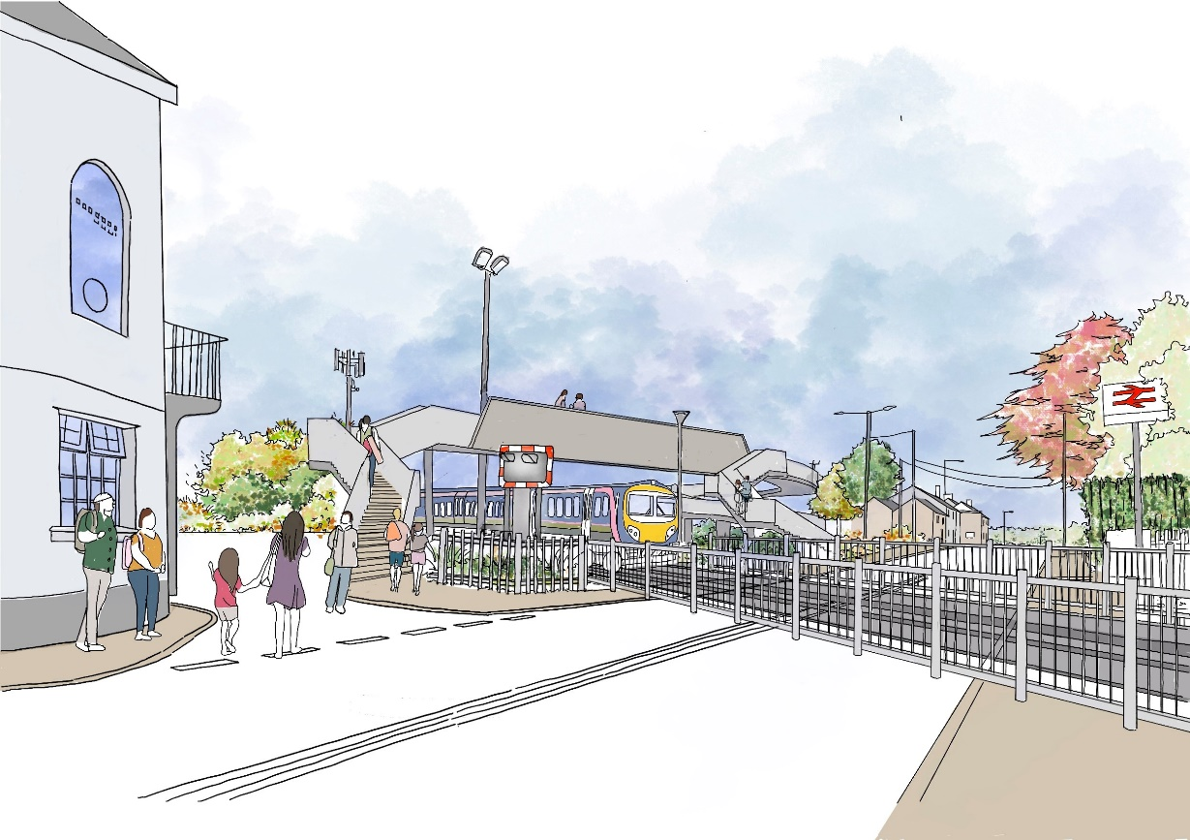

An artist impression of the new active travel bridge: (option 2)
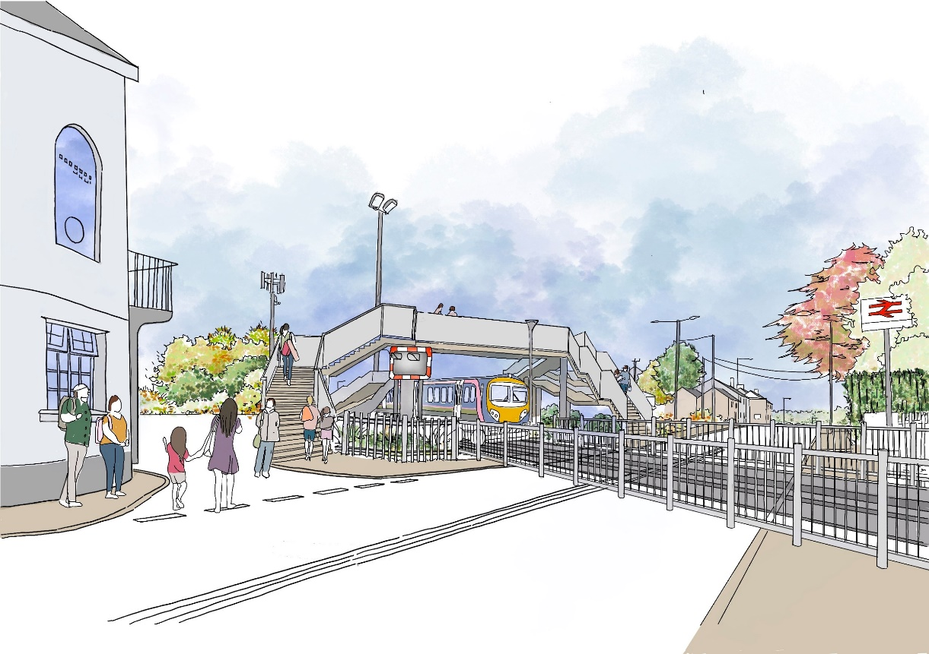

Penprysg Road Bridge would also be rebuilt to increase its capacity in both directions.

An artist impression of the developed Penprysg Road Bridge:
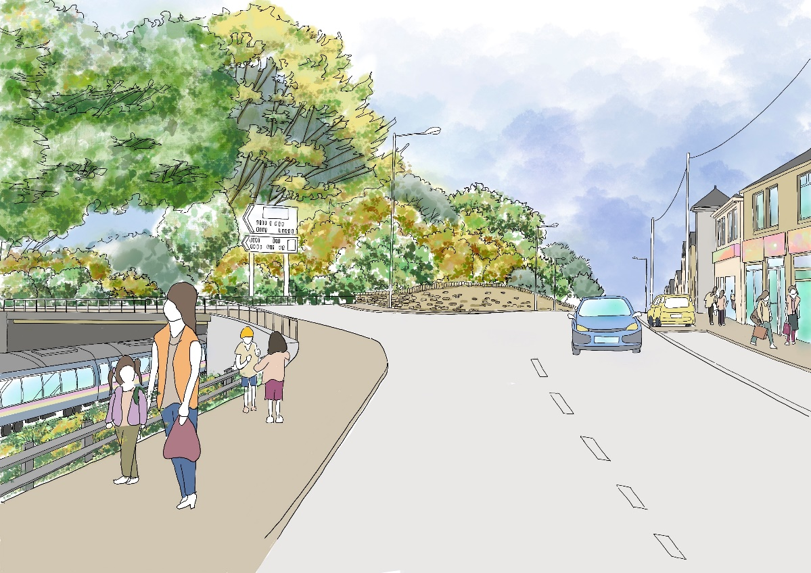

Impact of the proposals
Impact of the proposals on wellbeing will be assessed by the completion of the Wellbeing of Future Generations Assessment.
Impact of the proposals on people with protected characteristics, the impact on the use of the Welsh Language and the impact on socio-economic disadvantage will be carried out by the completion of the Equality Impact Assessment.

Finance
The current stage of this scheme, including feasibility studies and design is being funded by the Cardiff Capital Region City Deal (CCRCD) under the Metro programme. Subject to approval of the current proposals, the partners in this project including Bridgend County Borough Council, Network Rail and the Cardiff Capital Region City Deal will work collaboratively to secure funding for the construction of the project. The full financial cost has not been determined at this stage. It is anticipated that a full funding package would need to involve multiple funding sources. Detailed design work will determine full costs and timescales for the programme.

The consultation process
An important part of the process, when considering any development, is to gauge the views of the public and other stakeholders. The purpose of this consultation document is therefore to outline the proposed development. This document has been prepared to provide stakeholders with information about the new proposals to allow stakeholders the opportunity to have their say.

Following the conclusion of the consultation period all comments received will be presented to the local authority’s Cabinet and all views expressed will be taken into account when the Cabinet make any decision.
The table below sets out the timetable for the consultation:

Activity | Date
Response deadline | 6pm on Sunday 30 January 2022
Report to Cabinet on the outcomes of the consultation. | Tuesday 8 March 2022

How to respond
The local authority is asking the public and other stakeholders to answer the questions and provide their views via an on-line survey. The local authority is able to provide paper copies of the survey and in alternative formats, on request.
Please e-mail your request to consultation@bridgend.gov.uk or Tel. (01656) 643664
You can respond by sending paper survey forms to:
Post: Communications, Marketing and Engagement, Bridgend County Borough Council, Angel Street, Bridgend, CF31 4WB

The outcomes of the consultation will be reported to the Cabinet of Bridgend County Borough Council. If there is a decision not to proceed, that will be the end of this proposal and an alternative proposal may be sought.

Events
For those consultees who wish to the take the opportunity to ask questions about the plans consultation drop-in events will be held at the following venues:

Venue | Time | Date
Bridgend College – Pencoed Campus | 2pm to 4pm | Tuesday 9 November 2021
Pencoed Pavilion, Felindre Road | 10am to 12pm | Saturday 13 November 2021
Pencoed Town Council (Salem Chapel) | 6pm to 8pm | Monday 15 November 2021
Pencoed Library | 10am to 12pm | Friday 3 December 2021

