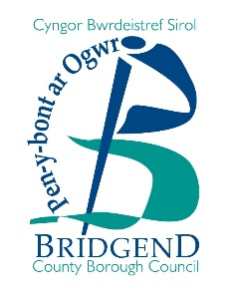
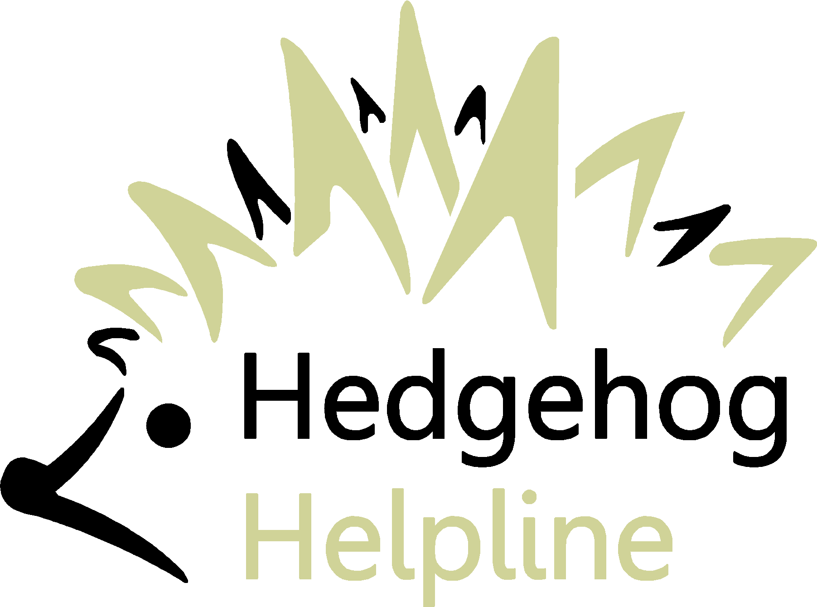
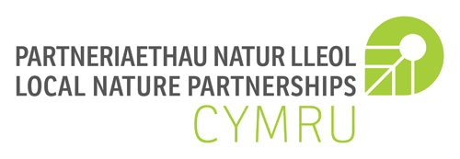
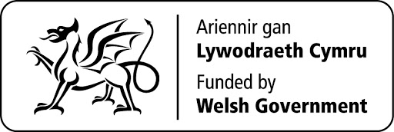
Urban Hedgehogs Pack
Bridgend Resident Application Form

This is an application form to request an Urban Hedgehog Pack from Bridgend County Borough Council. These packs will be allocated on a first come first served per ward basis to ensure a fair distribution across the borough. You MUST currently be a resident living with Bridgend County Borough and your garden must meet certain criteria to enable action for hedgehogs. Please accurately complete the following to provide us with the necessary information. Please send your completed application form to biodiversity@bridgend.gov.uk.

All information will be held in accordance with the Council’s Privacy Statement which can be found at www.bridgend.gov.uk/utility/privacy-statement/ or provided upon request. In summary, any information provided will be held by Bridgend County Borough Council only for the purposes of administering the scheme.

ABOUT YOU & YOUR HOUSEHOLD
First Name: |  |  |  | Last Name:
Address:
Postcode:
Tel: |  |  |  | Email:
Are there any children currently residing in the household?* |  | Yes | No | If yes, how many and ages?
Does your household include a dog?^ |  | Yes | No

*We are hoping to involve both adults and children in the activities that benefit our spiky friends as we want hedgehogs to still be around when our children are adults, so it’s important they know how to reduce and reverse the decline in hedgehog populations. However, households without children are still welcome to apply and will not be excluded.

^Some dogs can be quite territorial and may attack a hedgehog in their garden. If you have a dog, please assess whether this is likely to happen. An encounter between your dog and a hedgehog could lead to both animals being hurt.

ABOUT YOUR GARDEN
Do you currently see hedgehogs in your garden? | Yes | No
Does your garden currently include or have the potential for the following:
 | Yes | No | Potential
A ‘Hedgehog highway’ (an access point to and from your garden e.g. hole in a fence) | ☐ | ☐ | ☐
Log/habitat piles | ☐ | ☐ | ☐
Open air compost heap | ☐ | ☐ | ☐
Overgrown wild patch | ☐ | ☐ | ☐
Wildflower patch | ☐ | ☐ | ☐
Pond with adequate access points e.g. shallow areas or ramps to allow hedgehogs to get in and out easily | ☐ | ☐ | ☐

If you are successful in your application and you receive an Urban Hedgehog Pack we would love it if you provided us with photographs of your activity with the contents of the kit and regular updates. We would also really appreciate it if you helped us track local wild animals by using the Local Environmental Records Centre (LERC) mobile phone app (instructions will be included in your pack) for tracking wildlife in our area. We can help you with this if you are not able to do it or don’t have access to the technology to do it yourself. We also want you to stay in contact with us, at least once every six months, so you can let us know how things are going and whether any hedgehogs been visiting!
The information and feedback we receive will be used to gain a better understanding of the population and distribution of hedgehogs across the borough, as well as to determine how well the packages were received and how people are engaging with nature. Information collated may also be submitted to Welsh Government as an indication of how the funding for this project was spent; and to other wildlife organisations such Hedgehog Helpline. Please also tick the box below to give permission for any photographs submitted to be shared on our social media platforms.
Consent to process your information
I consent for Bridgend County Borough Council to process my information in line with the above for the purposes of processing this scheme.
Please tick this box: ☐
Consent to use photographs
I consent for Bridgend County Borough Council to use any photos that I provide on the promotional channels (e.g. social media) for the purposes of promoting this scheme. I confirm that I have consent of all people containing within any photos that I provide.
Please tick this box: ☐
The project is being funded by Welsh Governments Enabling of Natural Resources and Well-being Grant through the Local Nature Partnership Cymru Project, coordinated by the Wales Council for Voluntary Action. The project runs until April 2022 and is working towards a Wales that is a nature-rich nation that supports the nation’s well-being. More information can be found here: www.lnp.cymru.

